National University of Modern Languages

Sector H-9, Islamabad, Pakistan.

Department of Software Engineering

**HCI LAB Project**

**Designers:**

Umair Ali Arif (FL-23781)

Abdul Rafaih Mujeeb Abbasi (FL-23798)

Syed Iqtedar Mahdi (FL-23788)

**Section:** BSSE 5-B(Mor)

**Submitted to:** Mr. Khateeb Khan

**Subject:** HCI & G

**Date:** 21st December 2025

**Total Marks Obtained: ___________________**

**Instructor’s Signature: __________________**

Contents

Project Report: Redesign of the Pakistan Cricket Board (PCB) Website 3

1. Executive Summary 3

1.1. Summary of Applied Principles 4

2. Problem Statement: The Original Website 5

4. Visual Analysis of Redesigned Pages 5

4.1. Homepage 5

4.2. Match Center & Live Scores 6

4.3. Fixtures & Schedule 7

4.4. News & Updates 8

4.5. Multimedia (Videos) 9

10

4.6. Players 10

4.7. Corporate / About PCB 11

5. Contact 12

6. Backend: 13

7. Conclusion 14

CODE 14

FOR STYLING: 14

For Hall of Fame Page: 24

For Match Report: 27

For News Page: 30

For PCB page: 32

For Photos page: 39

For Players Page: 41

For Podcast Page: 48

JavaScript Files 50

● Fixtures Tab Switching (fixtures.js) 50

● Live Score Update (scores.js) 51

● Video Play Overlay (video.js) 51

Backend Implementation: 51

Php: 51

JS 54

Conclusion: 56

# Project Report: Redesign of the Pakistan Cricket Board (PCB) Website

**Project Name:** PCB Website Redesign

**Website Link:** [pcb.com.pk](https://pcb.com.pk)

**Design Philosophy:** Gestalt Principles of Visual Perception

## 1. Executive Summary

The Pakistan Cricket Board (PCB) serves as the governing body for cricket in Pakistan. Its official website is the primary hub for millions of fans seeking live scores, player statistics, news, and fixture updates. However, the original interface suffered from information overload, outdated navigational structures, and a lack of visual hierarchy.

This project focused on redesigning the PCB website to enhance User Experience (UX) and User Interface (UI) design. By rigorously applying specific **Gestalt Principles of Human Perception**—namely **Proximity, Similarity, Figure-Ground, Closure, Continuity, and Common Region**—the redesign aims to reduce cognitive load, improve navigation, and present a modern, professional digital identity for Pakistan Cricket.

### 1.1. Summary of Applied Principles

The following table outlines how specific Gestalt principles were utilized to enhance key sections of the website:

|  |  |  |  |
| --- | --- | --- | --- |
| **Website Page / Section** | **Gestalt Principle Applied** | **Design Implementation** | **Outcome** |
| **Homepage** | **Figure-Ground** | Large hero image with overlaid text versus a clean background. | Immediate focus on the featured story; emotional connection established. |
| **Navigation** | **Proximity** | Related menu links grouped together; distinct separation from content. | Improved scanability; users clearly distinguish "actions" from "content." |
| **Match Center** | **Similarity** | Consistent card layout, dimensions, and button styles for all matches. | Reduced cognitive load; users recognize the pattern instantly. |
| **Fixtures / Schedule** | **Continuity** | Linear timeline connecting dates and venues horizontally. | Guides the eye naturally across the schedule; improves flow. |
| **News Feed** | **Closure** | Use of whitespace (invisible lines) to form a grid structure. | Clean, organized layout without the need for heavy, cluttering borders. |
| **Videos** | **Figure-Ground** | High-contrast thumbnails with centered play buttons. | Video content "pops" out, encouraging engagement. |
| **Stats & Records** | **Similarity** | Zebra-striping (alternating colors) on data rows. | Easier horizontal tracking of complex data sets. |
| **Corporate / About** | **Common Region** | Distinct containers/borders for different departments. | Complex organizational info is chunked into digestible groups. |

## 2. Problem Statement: The Original Website

An analysis of the existing/original PCB website revealed several critical usability issues:

* **Information Clutter:** The homepage attempted to display too much information simultaneously (news, tweets, match summaries, corporate links) without clear prioritization.
* **Poor Visual Hierarchy:** It was difficult for users to distinguish between primary content (Live Matches) and secondary content (Archives/Corporate info).
* **Inconsistent Spacing:** Lack of consistent margins and padding led to a "cramped" feel, making text difficult to scan.
* **Outdated Navigation:** Deeply nested menus made it hard to find specific information like "Player Profiles" or "Domestic Stats."

## 4. Visual Analysis of Redesigned Pages

### 4.1. Homepage

*The clutter of list-based links is replaced by a dominant visual (Figure-Ground). Navigation is streamlined into clear categories (Proximity).*

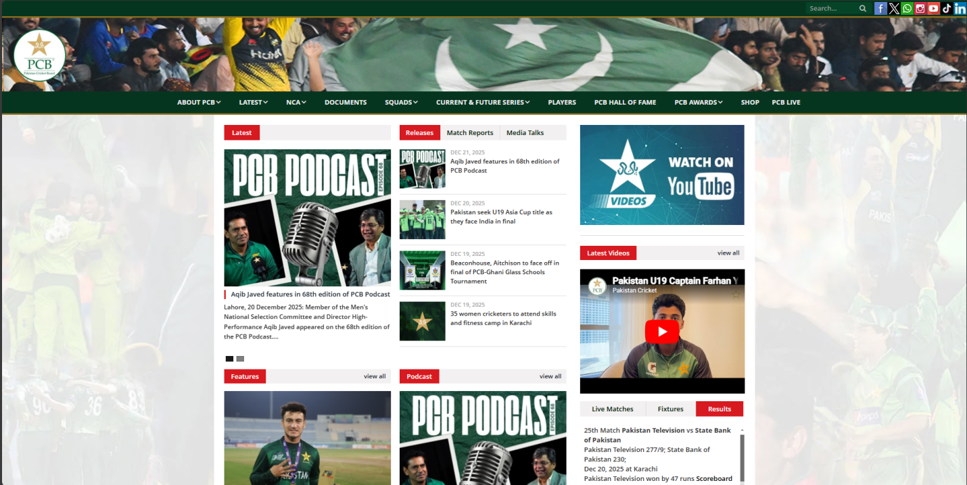Figure 1: Original PCB Website Homepage

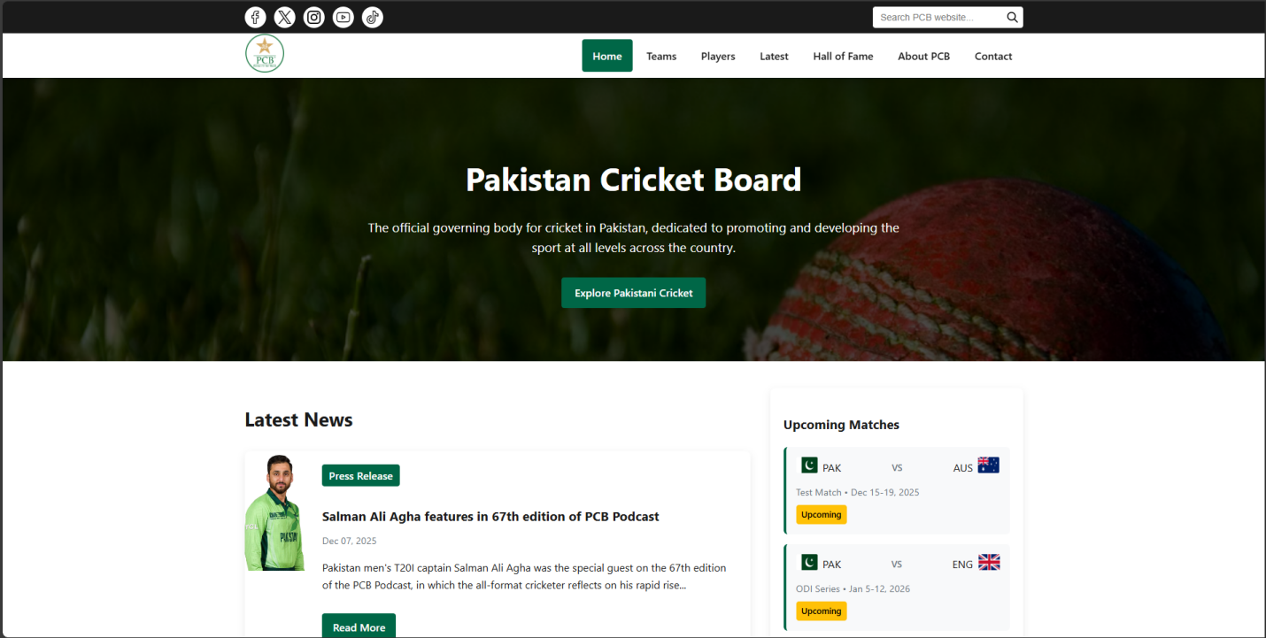Figure 2: Redesigned PCB Homepage

### 4.2. Match Center & Live Scores

*Scores are presented in clean, unified cards rather than a raw text list.*

* **Gestalt Application (Similarity):** Each match card shares the same dimension, shadow depth, and button placement, allowing users to scan multiple matches quickly without cognitive friction.
* **Gestalt Application (Proximity):** Team flags are placed immediately next to their scores, creating a distinct unit separate from the match status.

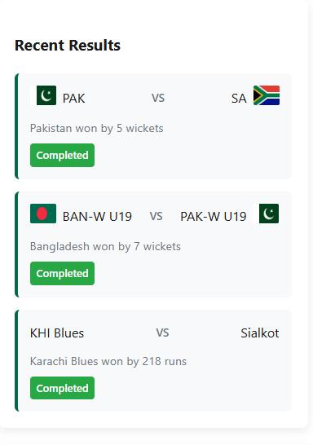

Figure 3: Redesigned Match Center

### 4.3. Fixtures & Schedule

*A chronological timeline layout replaces static tables.*

* **Gestalt Application (Continuity):** The timeline uses a horizontal line connecting dates and venues. This visual path guides the eye naturally from left to right (or top to bottom), helping users visualize the sequence of upcoming tours.
* **Gestalt Application (Common Region):** "International" and "Domestic" fixtures are separated into distinct tabbed regions, ensuring users don't mix up different tournament schedules.

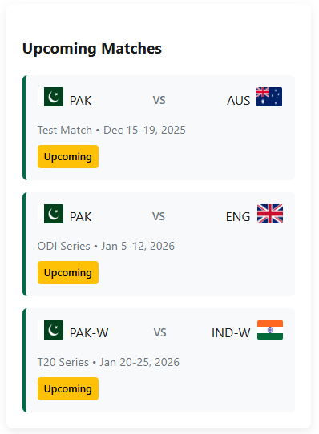

Figure 4: Redesigned Fixtures Page

### 4.4. News & Updates

*A grid layout replaces the vertical list, using consistent image sizes.*

* **Gestalt Application (Similarity):** All news items use identical typography hierarchies (Bold Title, Grey Subtitle). This consistency makes the page look orderly and professional.
* **Gestalt Application (Closure):** The grid structure uses whitespace rather than vertical lines to separate columns, trusting the eye to complete the grid pattern.

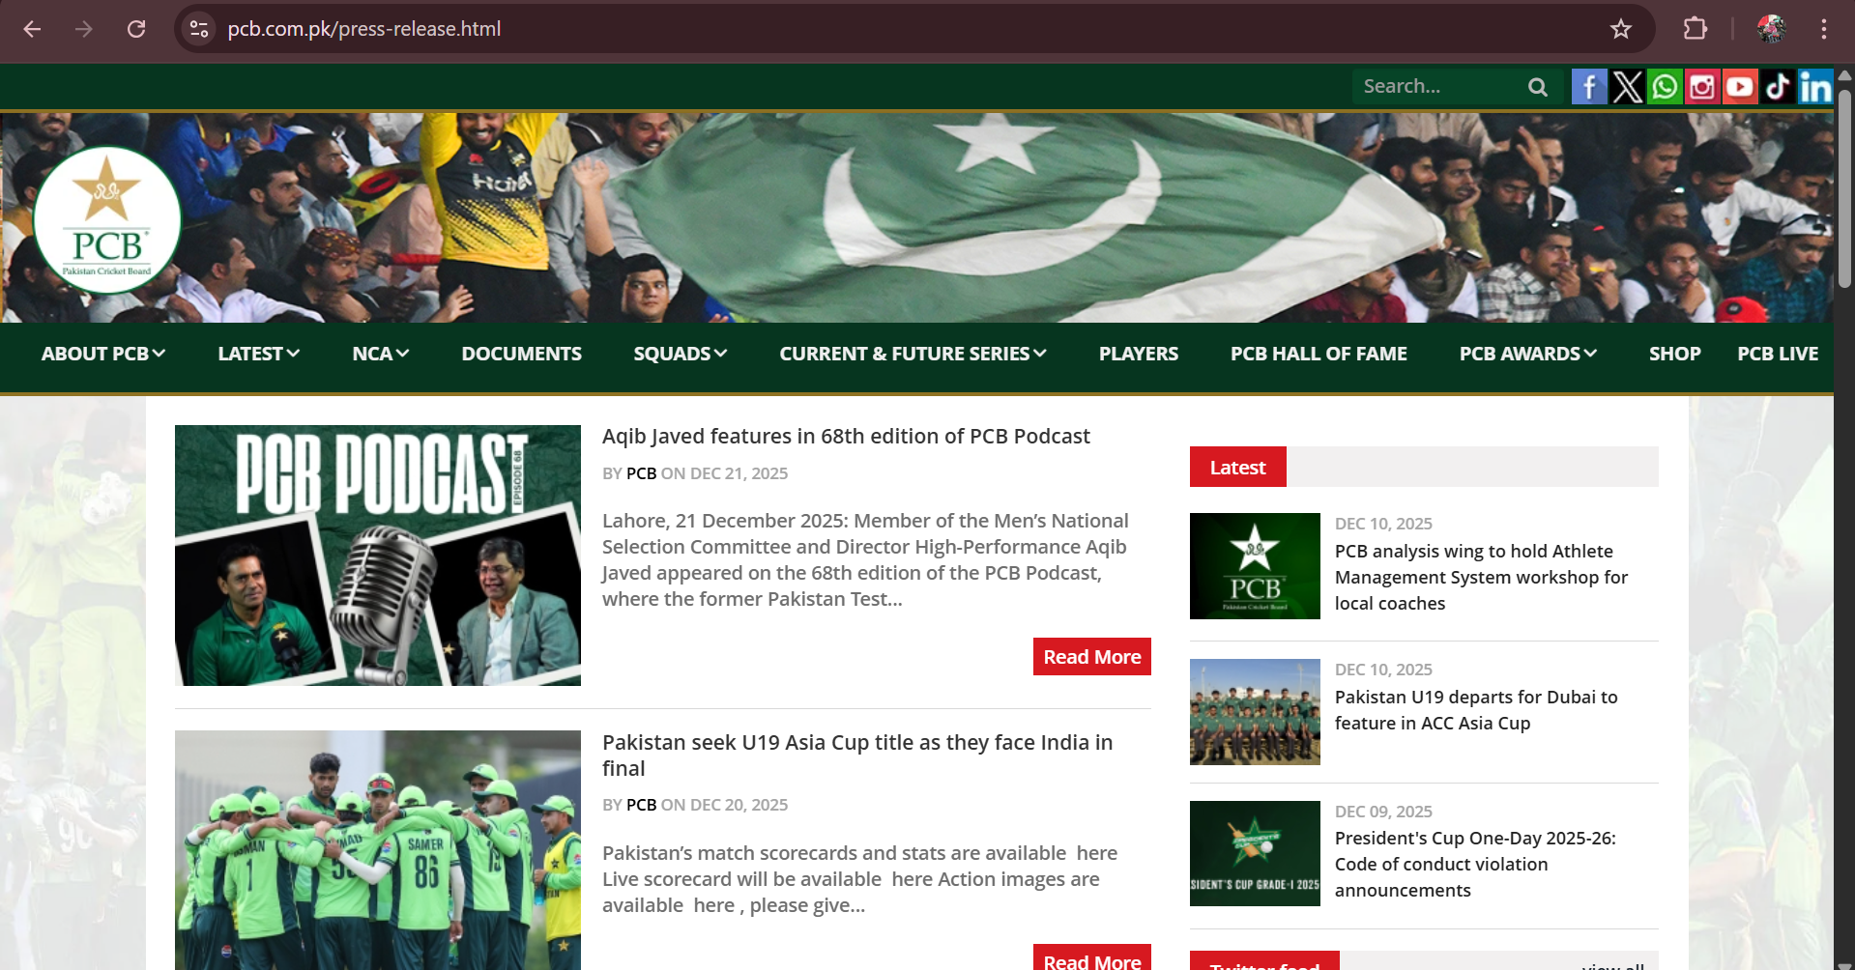

Original News Feed

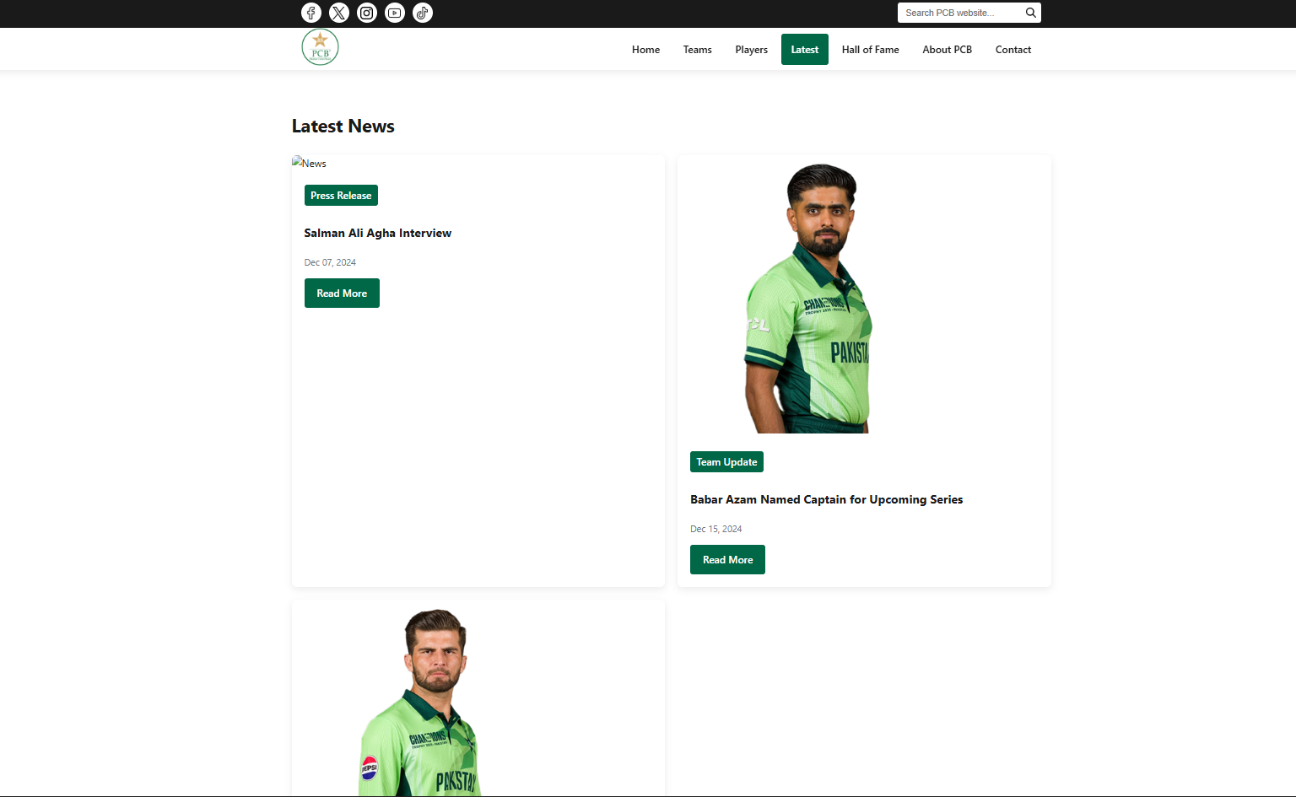

Figure 5: Redesigned News Feed

### 4.5. Multimedia (Videos)

*An immersive gallery view for match highlights and interviews.*

* **Gestalt Application (Figure-Ground):** Video thumbnails are large and bright against a darker background (or white space), making the content "pop" as the primary figure while the interface recedes.
* **Gestalt Application (Proximity):** Play buttons are centered on thumbnails, and titles are placed immediately below, ensuring the user knows exactly which text belongs to which video.

### 

Figure 6: Latest Videos Page

### 4.6. Players

*Clean data visualization for player rankings and historical records.*

* **Gestalt Application (Similarity):** Rows in data tables alternate slightly in shade (zebra striping). By making every other row similar in color, the eye can easily track horizontal data across a wide table.
* **Gestalt Application (Proximity, Similarity):** Created tiles instead of the lists that were present before. Which makes everything

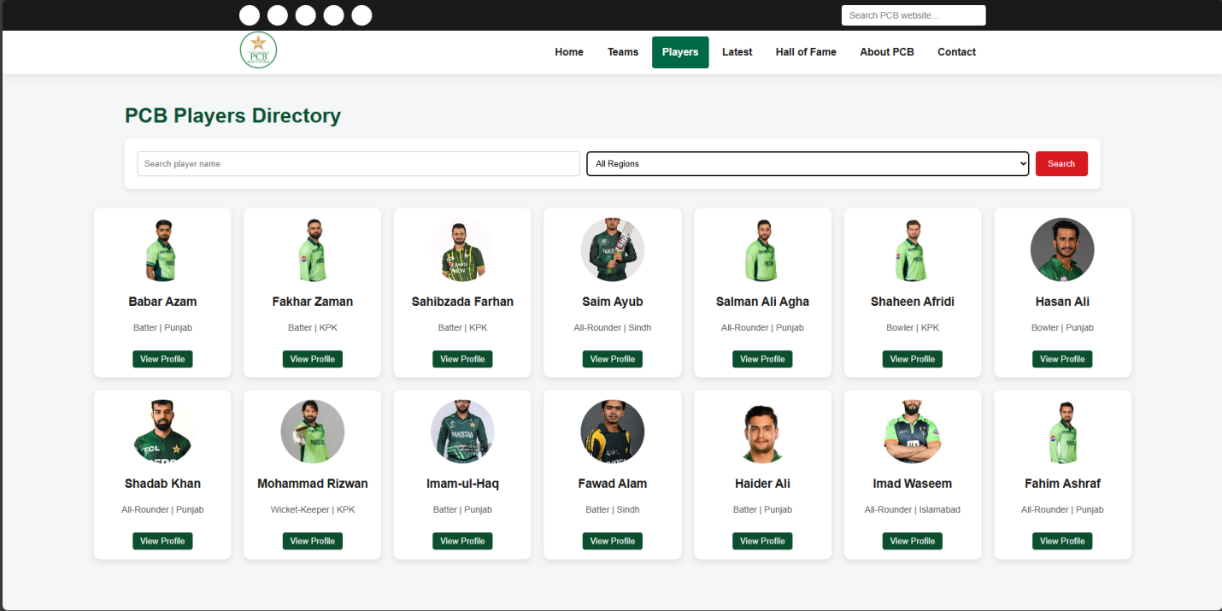

Figure 7: Redesigned Statistics Page

### 4.7. Corporate / About PCB

*A structured information page for board governance and history.*

* **Gestalt Application (Common Region):** Different departments (e.g., "Anti-Corruption," "Medical," "Finance") are housed in distinct card containers, organizing complex organizational structures into digestible chunks.
* **Gestalt Application (Closure):** Text is aligned strictly to the left grid line, creating a clean vertical axis without the need for a physical vertical divider.

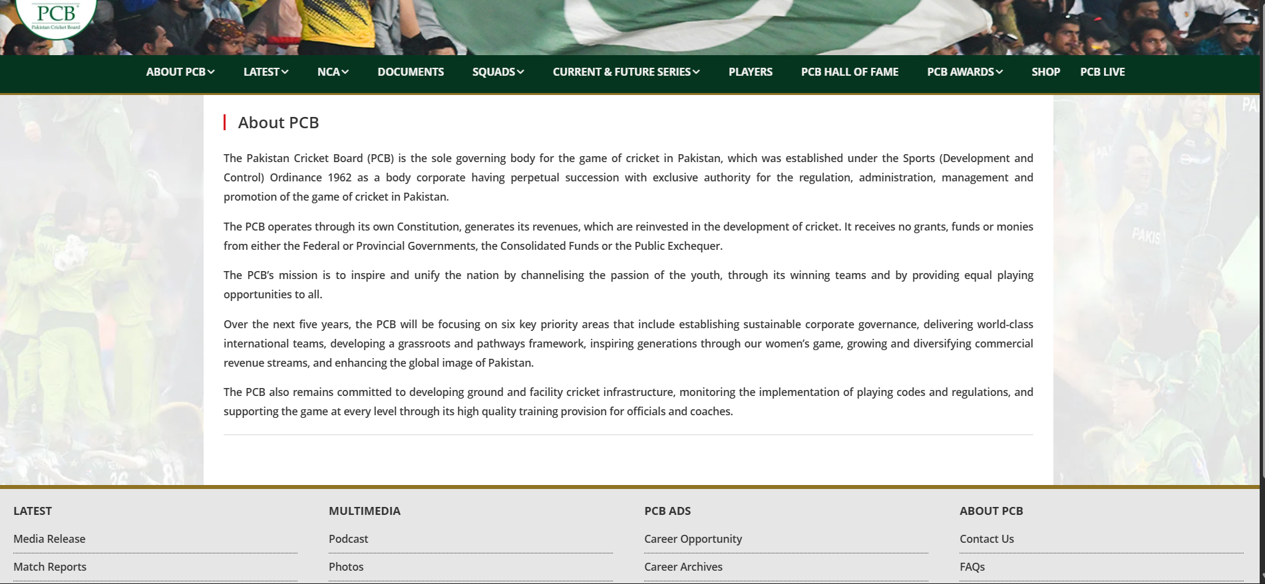

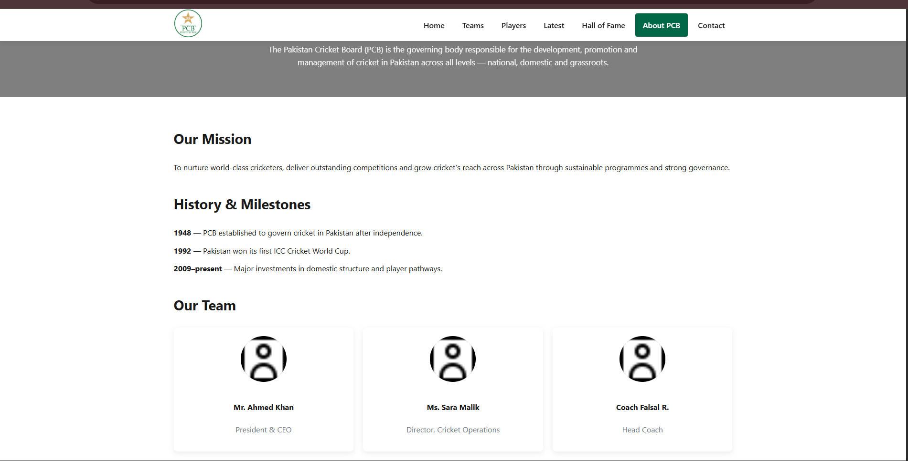

Figure 8: Redesigned Corporate Page

## Contact

Here are five positive aspects of its design and functionality:

**Professional Aesthetic:** The page features a clean and professional layout with a balanced use of white space, making the information easy to read and navigate.

**Clear Visual Hierarchy:** The use of bold headings, such as "Contact PCB" and "Send Us a Message," effectively guides the user's eye to the most important sections of the page.

**User-Friendly Contact Form:** The contact form is simple and intuitive, requesting only essential information which lowers the barrier for users to get in touch.

**Comprehensive Information:** By providing physical addresses, phone numbers, and specific email department links (media, partnerships), the page ensures users can reach the right department directly.

**Consistent Branding:** The header and the "Send Message" button utilize the signature green color of the PCB, maintaining strong brand consistency throughout the website.

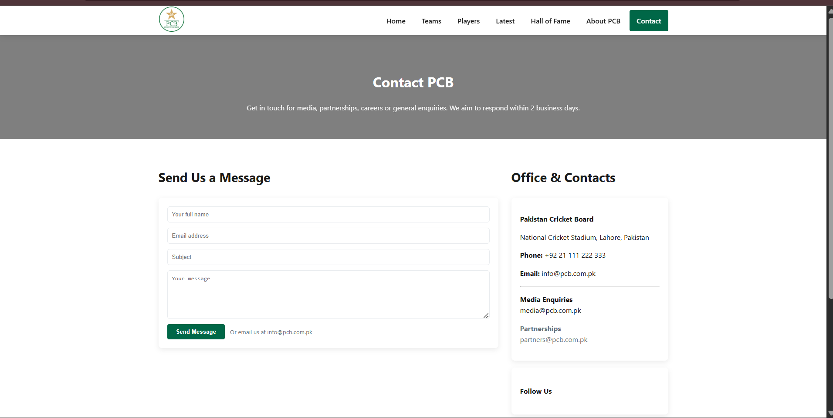

Redesigned for Contact page.

## Backend:

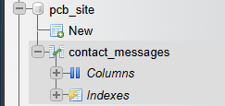

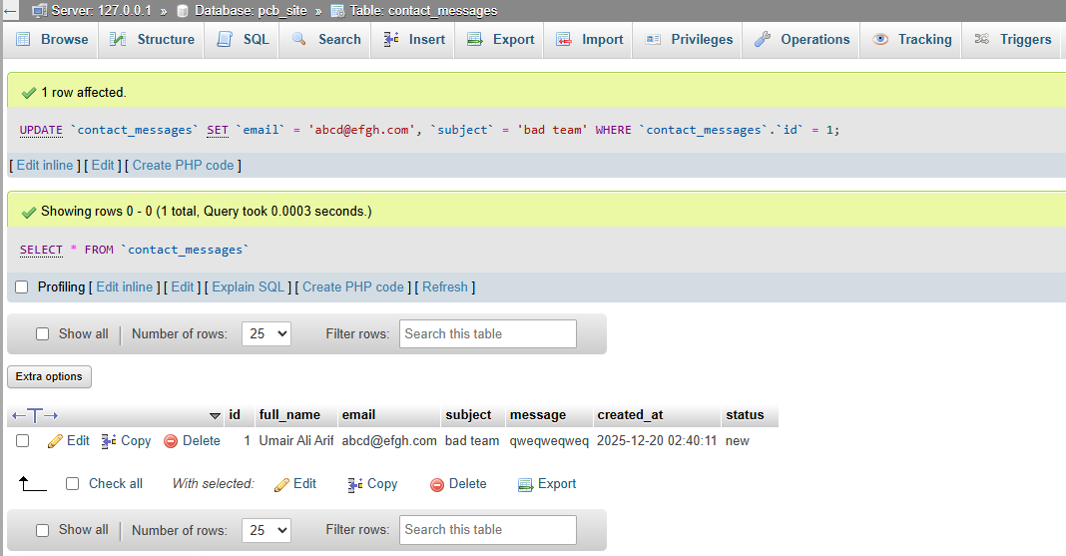

## Conclusion

The redesign of the PCB website moves away from a purely functional, data-heavy archive to a modern, user-centric digital experience. By leveraging Gestalt principles, the new interface directs user attention where it matters most, reduces visual noise, and reflects the dynamism of Pakistan Cricket. The result is a platform that is not only easier to use but also visually engaging and professional.

# CODE

## FOR STYLING:

/* Root Variables */

:root {

    --g: #006747;

    --g2: #008c5a;

    --gold: #d4af37;

    --light: #f8f9fa;

    --dark: #1a1a1a;

    --muted: #6c757d;

    --lt: #e9ecef;

    --shadow: 0 4px 12px rgba(0, 0, 0, 0.08);

    --trans: all 0.25s ease;

}

/* Reset & Global Styles */

*,

*::before,

*::after {

    box-sizing: border-box;

}

body {

    font-family: Segoe UI, Tahoma, Geneva, Verdana, sans-serif;

    color: var(--dark);

    background: #fff;

    margin: 0;

    line-height: 1.6;

}

a {

    color: inherit;

    text-decoration: none;

    transition: var(--trans);

}

img {

    max-width: 100%;

    height: auto;

}

/* Container */

.container {

    max-width: 1200px;

    margin: 0 auto;

    padding: 0 15px;

}

/* Buttons */

.btn {

    display: inline-block;

    background: var(--g);

    color: #fff;

    padding: 10px 20px;

    border-radius: 4px;

    font-weight: 600;

    border: none;

    cursor: pointer;

    transition: var(--trans);

}

.btn:hover {

    background: var(--g2);

    transform: translateY(-2px);

}

.btn--small {

    padding: 8px 16px;

}

.btn--full {

    width: 100%;

    text-align: center;

}

/* Top Bar */

.top-bar {

    background: var(--dark);

    color: #fff;

    padding: 8px 0;

    font-size: 0.9rem;

}

.top-bar .top-bar-content,

.header-content {

    display: flex;

    justify-content: space-between;

    align-items: center;

}

/* Social Icons */

.social-icons {

    display: flex;

    gap: 12px;

}

.social-icons a {

    width: 32px;

    height: 32px;

    border-radius: 50%;

    display: inline-flex;

    align-items: center;

    justify-content: center;

    background: #ffffff;

    transition: var(--trans);

    padding: 6px;

}

.social-icons a:hover {

    background: var(--gold);

    transform: scale(1.1);

}

.social-icons a img {

    width: 100%;

    height: 100%;

    object-fit: contain;

}

/* Search Form */

.search-form {

    display: flex;

    align-items: center;

}

.search-form input {

    padding: 6px 12px;

    border: 0;

    border-radius: 4px 0 0 4px;

    height: 32px;

    font-size: 14px;

}

.search-form button {

    background: #ffffff;

    color: #fff;

    border: 0;

    padding: 0;

    border-radius: 0 4px 4px 0;

    cursor: pointer;

    transition: var(--trans);

    display: flex;

    align-items: center;

    justify-content: center;

    width: 32px;

    height: 32px;

    flex-shrink: 0;

}

.search-form button:hover {

    background: var(--gold);

}

.search-form button img {

    width: 16px;

    height: 16px;

    object-fit: contain;

}

/* Main Header */

.main-header {

    background: #fff;

    box-shadow: var(--shadow);

    position: sticky;

    top: 0;

    z-index: 1000;

}

.logo img {

    height: 60px;

}

/* Navigation */

.main-nav ul {

    display: flex;

    gap: 5px;

    align-items: center;

    padding: 0;

    margin: 0;

    list-style: none;

}

.main-nav li {

    position: relative;

    list-style: none;

}

.main-nav a {

    display: block;

    padding: 12px 16px;

    font-weight: 600;

    border-radius: 4px;

    transition: var(--trans);

}

.main-nav a:hover {

    background: var(--lt);

    color: var(--g);

}

.main-nav a.active {

    background: var(--g);

    color: #fff;

}

/* Dropdown */

.dropdown {

    position: absolute;

    top: 100%;

    left: 0;

    background: #fff;

    min-width: 220px;

    box-shadow: var(--shadow);

    border-radius: 0 0 4px 4px;

    opacity: 0;

    visibility: hidden;

    transform: translateY(10px);

    transition: var(--trans);

}

.main-nav li:hover > .dropdown {

    opacity: 1;

    visibility: visible;

    transform: translateY(0);

}

.dropdown a {

    padding: 10px 16px;

    display: block;

    border-bottom: 1px solid var(--lt);

}

.dropdown a:last-child {

    border-bottom: 0;

}

/* Mobile Menu Button */

.mobile-menu-btn {

    display: none;

    font-size: 1.5rem;

    background: none;

    border: 0;

    cursor: pointer;

    color: var(--dark);

}

/* Hero Section */

.hero {

    background: linear-gradient(rgba(0, 0, 0, 0.7), rgba(0, 0, 0, 0.7)),

        url('https://images.unsplash.com/photo-1531415074968-036ba1b575da?ixlib=rb-4.0.3&auto=format&fit=crop&w=1200&q=80')

        center / cover;

    padding: 80px 0;

    color: #fff;

    text-align: center;

    margin-bottom: 40px;

}

.hero h1 {

    font-size: 3rem;

    margin-bottom: 20px;

}

.hero p {

    max-width: 800px;

    margin: 0 auto 30px;

    font-size: 1.2rem;

}

/* Main Content Layout */

.main-content {

    display: grid;

    grid-template-columns: 2fr 1fr;

    gap: 30px;

    margin-bottom: 50px;

}

/* News Grid */

.news-grid {

    display: grid;

    grid-template-columns: repeat(2, 1fr);

    gap: 20px;

}

/* News Card */

.news-card {

    background: #fff;

    border-radius: 8px;

    overflow: hidden;

    box-shadow: var(--shadow);

    transition: var(--trans);

}

.news-card:hover {

    transform: translateY(-5px);

    box-shadow: 0 10px 20px rgba(0, 0, 0, 0.1);

}

.news-card.large {

    grid-column: span 2;

    display: flex;

}

.news-image {

    height: 180px;

    overflow: hidden;

}

.news-image img {

    width: 100%;

    height: 100%;

    object-fit: cover;

    transition: var(--trans);

}

.news-card:hover .news-image img {

    transform: scale(1.05);

}

.news-content {

    padding: 20px;

}

.news-category {

    display: inline-block;

    background: var(--g);

    color: #fff;

    padding: 4px 10px;

    border-radius: 4px;

    font-weight: 600;

    margin-bottom: 10px;

}

.news-title {

    font-size: 1.2rem;

    margin-bottom: 10px;

}

.news-date {

    color: var(--muted);

    font-size: 0.9rem;

    margin-bottom: 15px;

}

/* Sponsors Section */

.sponsors-section {

    background: var(--light);

    padding: 40px 0;

    text-align: center;

}

.sponsors-grid {

    display: grid;

    grid-template-columns: repeat(auto-fit, minmax(150px, 1fr));

    gap: 25px;

    align-items: center;

    margin-top: 30px;

}

.sponsor-item {

    background: #fff;

    padding: 20px;

    border-radius: 8px;

    box-shadow: var(--shadow);

    display: flex;

    align-items: center;

    justify-content: center;

    height: 100px;

}

.sponsor-item img {

    max-height: 60px;

    filter: grayscale(100%);

    opacity: 0.8;

    transition: var(--trans);

}

.sponsor-item:hover img {

    filter: none;

    opacity: 1;

}

/* Sidebar Widget & Feature Card */

.sidebar-widget,

.feature-card {

    background: #fff;

    border-radius: 8px;

    padding: 20px;

    box-shadow: var(--shadow);

}

.sidebar-widget {

    margin-bottom: 20px;

}

/* Feature Section */

.feature-icon {

    height: 120px;

    background: var(--g);

    display: flex;

    align-items: center;

    justify-content: center;

    color: #fff;

    font-size: 2.5rem;

    margin-bottom: 15px;

}

.features-grid {

    display: grid;

    grid-template-columns: repeat(3, 1fr);

    gap: 20px;

}

/* Section Title */

.section-title {

    font-size: 1.8rem;

    margin-bottom: 25px;

    color: var(--dark);

}

.widget-title {

    font-size: 1.2rem;

    margin-bottom: 20px;

    color: var(--dark);

}

.feature-title {

    font-size: 1.1rem;

    margin-bottom: 10px;

    color: var(--dark);

}

/* Match List */

.match-list {

    display: flex;

    flex-direction: column;

    gap: 15px;

}

.match-item {

    padding: 15px;

    background: var(--light);

    border-radius: 6px;

    border-left: 4px solid var(--g);

}

.match-teams {

    display: flex;

    justify-content: space-between;

    align-items: center;

    margin-bottom: 10px;

}

.team {

    display: flex;

    align-items: center;

    gap: 8px;

}

.team-flag img {

    height: 24px;

    width: 32px;

    border-radius: 2px;

}

.vs {

    font-weight: 600;

    color: var(--muted);

    font-size: 0.85rem;

}

.match-result {

    font-size: 0.9rem;

    color: var(--muted);

    margin-bottom: 8px;

}

.match-status {

    display: inline-block;

    background: #ffc107;

    color: #000;

    padding: 4px 8px;

    border-radius: 4px;

    font-size: 0.8rem;

    font-weight: 600;

}

.match-status--completed {

    background-color: #28a745;

    color: #fff;

}

/* Button Variations */

.btn-read-more,

.btn-widget-full,

.btn-feature {

    margin-top: 15px;

}

/* Quick Links */

.quick-links {

    list-style: none;

    padding: 0;

    margin: 0;

}

.quick-links li {

    margin-bottom: 10px;

}

.quick-links i {

    margin-right: 8px;

    color: var(--g);

}

/* Footer */

.main-footer {

    background: var(--dark);

    color: #fff;

    padding: 50px 0 20px;

}

.footer-content {

    display: grid;

    grid-template-columns: repeat(4, 1fr);

    gap: 30px;

    margin-bottom: 30px;

}

.footer-widget h3 {

    font-size: 1.2rem;

    margin-bottom: 20px;

    padding-bottom: 10px;

    border-bottom: 2px solid var(--g);

}

.footer-widget ul {

    list-style: none;

    padding: 0;

    margin: 0;

}

.footer-widget ul li {

    margin-bottom: 10px;

}

.footer-widget ul li a:hover {

    color: var(--gold);

    padding-left: 5px;

}

.copyright {

    text-align: center;

    padding-top: 20px;

    border-top: 1px solid rgba(255, 255, 255, 0.1);

    color: rgba(255, 255, 255, 0.7);

    font-size: 0.9rem;

}

/* Responsive Design */

@media (max-width: 992px) {

    .main-content {

        grid-template-columns: 1fr;

    }

    .features-grid {

        grid-template-columns: repeat(2, 1fr);

    }

    .footer-content {

        grid-template-columns: repeat(2, 1fr);

    }

}

@media (max-width: 768px) {

    .mobile-menu-btn {

        display: block;

    }

    .main-nav ul {

        display: none;

        position: absolute;

        top: 100%;

        left: 0;

        width: 100%;

        background: #fff;

        flex-direction: column;

        box-shadow: var(--shadow);

        border-radius: 0 0 8px 8px;

        z-index: 100;

    }

    .main-nav.active ul {

        display: flex;

    }

    .main-nav > ul > li > a {

        padding: 15px 20px;

        border-bottom: 1px solid var(--lt);

    }

    .dropdown {

        position: static;

        opacity: 1;

        visibility: visible;

        transform: none;

        box-shadow: none;

        border-radius: 0;

        display: none;

    }

    .main-nav > ul > li:hover > .dropdown {

        display: block;

    }

    .hero h1 {

        font-size: 2.2rem;

    }

    .news-grid {

        grid-template-columns: 1fr;

    }

    .news-card.large {

        flex-direction: column;

    }

    .features-grid {

        grid-template-columns: 1fr;

    }

    .sponsors-grid {

        grid-template-columns: repeat(2, 1fr);

    }

}

@media (max-width: 576px) {

    .hero {

        padding: 60px 0;

    }

    .hero h1 {

        font-size: 1.8rem;

    }

    .footer-content {

        grid-template-columns: 1fr;

    }

    .sponsors-grid {

        grid-template-columns: 1fr;

    }

}

## For Hall of Fame Page:

<!DOCTYPE html>

<html lang="en">

<head>

    <meta charset="utf-8">

    <meta name="viewport" content="width=device-width, initial-scale=1">

    <title>PCB Hall of Fame</title>

    <link rel="stylesheet" href="assets/css/fontawesome/css/all.min.css">

    <link rel="stylesheet" href="style.css">

    <style>

        .hof-hero{padding:60px 0;text-align:center;color:#fff;background:linear-gradient(rgba(0,0,0,.5),rgba(0,0,0,.5)),url('Media/halloffame-hero.jpg') center/cover}

        .inductees-grid{display:grid;grid-template-columns:repeat(auto-fit,minmax(220px,1fr));gap:20px}

        .inductee{background:#fff;padding:18px;border-radius:8px;box-shadow:var(--shadow);text-align:center}

        .inductee img{width:120px;height:120px;border-radius:50%;object-fit:cover;margin-bottom:12px}

        .filter-row{display:flex;gap:12px;align-items:center;margin-bottom:18px}

        @media(max-width:600px){.filter-row{flex-direction:column;align-items:stretch}}

    </style>

</head>

<body>

    <!-- Header -->

    <header class="main-header">

        <div class="container">

            <div class="header-content">

                <div class="logo">

                    <a href="pcb.html"><img src="Media/pcb-logo.png" alt="PCB"></a>

                </div>

                <nav class="main-nav">

                    <button class="mobile-menu-btn"><i class="fas fa-bars"></i></button>

                    <ul>

                        <li><a href="pcb.html">Home</a></li>

                        <li>

                            <a href="#">Teams <i class="fas fa-chevron-down"></i></a>

                            <ul class="dropdown">

                                <li><a href="#">Men's National Team</a></li>

                                <li><a href="#">Women's National Team</a></li>

                                <li><a href="#">U19 Teams</a></li>

                                <li><a href="#">Domestic Teams</a></li>

                            </ul>

                        </li>

                        <li><a href="#">Players</a></li>

                        <li>

                            <a href="#">Latest <i class="fas fa-chevron-down"></i></a>

                            <ul class="dropdown">

                                <li><a href="News.html">News</a></li>

                                <li><a href="match_report.html">Match Reports</a></li>

                                <li><a href="photos.html">Photos</a></li>

                                <li><a href="videos.html">Videos</a></li>

                                <li><a href="podcast.html">Podcasts</a></li>

                            </ul>

                        </li>

                        <li><a href="halloffame.html" class="active">Hall of Fame</a></li>

                        <li><a href="About.html">About PCB</a></li>

                        <li><a href="contact.html">Contact</a></li>

                    </ul>

                </nav>

            </div>

        </div>

    </header>

    <!-- Hero -->

    <section class="hof-hero">

        <div class="container">

            <h1>PCB Hall of Fame</h1>

            <p style="max-width:800px;margin:12px auto 0;opacity:.95">Honouring the players, coaches and contributors who have shaped Pakistani cricket.</p>

        </div>

    </section>

    <main class="container" style="padding:40px 15px 80px">

        <section>

            <h2 class="section-title">Inductees</h2>

            <div class="filter-row">

                <input type="search" id="hof-search" placeholder="Search inductees by name..." style="padding:8px;border-radius:6px;border:1px solid var(--lt);flex:1">

                <select id="hof-era" style="padding:8px;border-radius:6px;border:1px solid var(--lt)">

                    <option value="all">All eras</option>

                    <option value="pre2000">Pre-2000</option>

                    <option value="2000s">2000s</option>

                    <option value="2010s">2010s+</option>

                </select>

            </div>

            <div class="inductees-grid" id="inductees">

                <div class="inductee" data-era="pre2000">

                    <img src="Media/hanif.jpeg" alt="Legend 1">

                    <h4>Hanif Mohammad</h4>

                    <p style="color:var(--muted)">Batsman — Inducted 2005</p>

                </div>

                <div class="inductee" data-era="pre2000">

                    <img src="Media/imran.jpeg" alt="Legend 2">

                    <h4>Imran Khan</h4>

                    <p style="color:var(--muted)">All-rounder — Inducted 2008</p>

                </div>

                <div class="inductee" data-era="2000s">

                    <img src="Media/wasim.jpeg" alt="Legend 3">

                    <h4>Wasim Akram</h4>

                    <p style="color:var(--muted)">Fast Bowler — Inducted 2012</p>

                </div>

                <div class="inductee" data-era="2010s">

                    <img src="media/younis.jpeg" alt="Legend 4">

                    <h4>Younis Khan</h4>

                    <p style="color:var(--muted)">Batsman — Inducted 2018</p>

                </div>

            </div>

        </section>

        <section style="margin-top:40px">

            <h2 class="section-title">Nominate a Candidate</h2>

            <p>Know someone who should be in the Hall of Fame? Send us a nomination with reasons and supporting references.</p>

            <form style="max-width:700px;margin-top:12px">

                <input type="text" placeholder="Full name" required style="width:100%;padding:10px;border-radius:6px;border:1px solid var(--lt);margin-bottom:8px">

                <input type="email" placeholder="Your email" required style="width:100%;padding:10px;border-radius:6px;border:1px solid var(--lt);margin-bottom:8px">

                <textarea placeholder="Why nominate this person?" rows="5" style="width:100%;padding:10px;border-radius:6px;border:1px solid var(--lt);margin-bottom:8px"></textarea>

                <button class="btn" type="submit">Submit Nomination</button>

            </form>

        </section>

    </main>

    <footer class="main-footer">

        <div class="container">

            <div class="footer-content">

                <div class="footer-widget">

                    <h3>About PCB</h3>

                    <ul>

                        <li><a href="About.html">About Us</a></li>

                        <li><a href="#">Board of Governors</a></li>

                    </ul>

                </div>

                <div class="footer-widget">

                    <h3>Connect</h3>

                    <ul>

                        <li><a href="#">PCB Live</a></li>

                        <li><a href="#">PCB Shop</a></li>

                    </ul>

                </div>

                <div class="footer-widget">

                    <h3>Support</h3>

                    <ul>

                        <li><a href="#">Careers</a></li>

                    </ul>

                </div>

                <div class="footer-widget">

                    <h3>Media</h3>

                    <ul>

                        <li><a href="#">News</a></li>

                    </ul>

                </div>

            </div>

            <div class="copyright">

                <p>&copy; 2025 Pakistan Cricket Board.</p>

            </div>

        </div>

    </footer>

    <script>

        // small client-side filtering for the inductees grid

        (function(){

            const search = document.getElementById('hof-search');

            const era = document.getElementById('hof-era');

            const grid = document.getElementById('inductees');

            const items = Array.from(grid.children);

            function applyFilter(){

                const q = search.value.trim().toLowerCase();

                const e = era.value;

                items.forEach(it=>{

                    const name = it.querySelector('h4').textContent.toLowerCase();

                    const itemEra = it.getAttribute('data-era') || 'all';

                    const matchQ = !q || name.includes(q);

                    const matchEra = e==='all' || itemEra===e || (e==='2000s' && itemEra==='2000s') || (e==='2010s' && itemEra==='2010s');

                    it.style.display = (matchQ && matchEra) ? '' : 'none';

                });

            }

            search.addEventListener('input',applyFilter);

            era.addEventListener('change',applyFilter);

        })();

    </script>

</body>

</html>

## For Match Report:

<!DOCTYPE html>

<html lang="en">

<head>

    <meta charset="UTF-8">

    <meta name="viewport" content="width=device-width, initial-scale=1.0">

    <title>Match Reports | PCB</title>

    <link rel="stylesheet" href="assets/css/fontawesome/css/all.min.css">

    <link rel="stylesheet" href="style.css">

</head>

<body>

    <!-- Top Bar -->

    <div class="top-bar">

        <div class="container">

            <div class="top-bar-content">

                <div class="social-icons">

                    <a href="https://www.facebook.com/PakistanCricketBoard" target="_blank"><img src="Media/facebook.png" alt="Facebook"></a>

                    <a href="https://www.twitter.com/TheRealPCB" target="_blank"><img src="Media/twitter.png" alt="Twitter"></a>

                    <a href="https://www.instagram.com/therealpcb" target="_blank"><img src="Media/instagram-logo.png" alt="Instagram"></a>

                    <a href="https://www.youtube.com/channel/UCiWrjBhlICf_L_RK5y6Vrxw" target="_blank"><img src="Media/youtube.png" alt="YouTube"></a>

                    <a href="https://www.tiktok.com/@pcb" target="_blank"><img src="Media/tik-tok.png" alt="TikTok"></a>

                </div>

                <form class="search-form">

                    <input type="text" placeholder="Search PCB website...">

                    <button type="submit"><img src="Media/search.png" alt="Search"></button>

                </form>

            </div>

        </div>

    </div>

    <!-- Main Header -->

    <header class="main-header">

        <div class="container">

            <div class="header-content">

                <div class="logo">

                    <a href="pcb.html"><img src="Media/pcb-logo.png" alt="Pakistan Cricket Board"></a>

                </div>

                <nav class="main-nav">

                    <button class="mobile-menu-btn"><i class="fas fa-bars"></i></button>

                    <ul>

                        <li><a href="pcb.html">Home</a></li>

                        <li>

                            <a href="#">Teams <i class="fas fa-chevron-down"></i></a>

                            <ul class="dropdown">

                                <li><a href="#">Men's National Team</a></li>

                                <li><a href="#">Women's National Team</a></li>

                                <li><a href="#">U19 Teams</a></li>

                                <li><a href="#">Domestic Teams</a></li>

                            </ul>

                        </li>

                        <li><a href="players.html">Players</a></li>

                        <li>

                            <a href="#" class="active">Latest <i class="fas fa-chevron-down"></i></a>

                            <ul class="dropdown">

                                <li><a href="News.html">News</a></li>

                                <li><a href="match_report.html">Match Reports</a></li>

                                <li><a href="photos.html">Photos</a></li>

                                <li><a href="videos.html">Videos</a></li>

                                <li><a href="podcast.html">Podcasts</a></li>

                            </ul>

                        </li>

                        <li><a href="halloffame.html">Hall of Fame</a></li>

                        <li><a href="About.html">About PCB</a></li>

                        <li><a href="contact.html">Contact</a></li>

                    </ul>

                </nav>

            </div>

        </div>

    </header>

    <main class="container" style="padding: 40px 0;">

        <h2 class="section-title">Match Reports</h2>

        <div style="background:#fff; padding:25px; border-radius:8px; box-shadow:var(--shadow); border-left:5px solid var(--g); margin-bottom:20px;">

            <div style="display:flex; justify-content:space-between; margin-bottom:10px;">

                <span style="background:var(--g); color:#fff; padding:2px 10px; border-radius:4px; font-size:12px;">Completed</span>

                <span style="color:var(--muted); font-size:12px;">Dec 05, 2024</span>

            </div>

            <h3>PAK vs SA - 1st Test Match</h3>

            <div style="display:flex; gap:20px; align-items:center; margin:15px 0;">

                <div style="display:flex; align-items:center; gap:8px;">

                    <img src="Media/pakistan.png" alt="PAK" style="width:24px; height:16px;">

                    <span style="font-weight:600;">PAK 285/5</span>

                </div>

                <span style="color:var(--muted);">vs</span>

                <div style="display:flex; align-items:center; gap:8px;">

                    <img src="Media/south-africa.png" alt="SA" style="width:24px; height:16px;">

                    <span>SA 281/10</span>

                </div>

            </div>

            <p>Pakistan secured a thrilling 5-wicket victory over South Africa in Karachi. Babar Azam's masterful 127 anchored the chase as Pakistan reached their target with 12 balls to spare. Earlier, South Africa posted 281 with Du Plessis scoring 89.</p>

            <a href="#" class="btn btn-g" style="margin-top:10px;">Read Full Report</a>

        </div>

        <div style="background:#fff; padding:25px; border-radius:8px; box-shadow:var(--shadow); border-left:5px solid var(--g); margin-bottom:20px;">

            <div style="display:flex; justify-content:space-between; margin-bottom:10px;">

                <span style="background:var(--g); color:#fff; padding:2px 10px; border-radius:4px; font-size:12px;">Completed</span>

                <span style="color:var(--muted); font-size:12px;">Nov 28, 2024</span>

            </div>

            <h3>BAN-W U19 vs PAK-W U19 - Women's U19 T20</h3>

            <div style="display:flex; gap:20px; align-items:center; margin:15px 0;">

                <div style="display:flex; align-items:center; gap:8px;">

                    <img src="Media/bangladesh.png" alt="BAN" style="width:24px; height:16px;">

                    <span style="font-weight:600;">BAN-W U19 142/3</span>

                </div>

                <span style="color:var(--muted);">vs</span>

                <div style="display:flex; align-items:center; gap:8px;">

                    <img src="Media/pakistan.png" alt="PAK" style="width:24px; height:16px;">

                    <span>PAK-W U19 138/10</span>

                </div>

            </div>

            <p>Bangladesh Women U19 defeated Pakistan Women U19 by 4 runs in a closely contested T20 match. Chasing 143, Pakistan fell just short despite a valiant effort from their lower order.</p>

            <a href="#" class="btn btn-g" style="margin-top:10px;">Read Full Report</a>

        </div>

        <div style="background:#fff; padding:25px; border-radius:8px; box-shadow:var(--shadow); border-left:5px solid var(--g);">

            <div style="display:flex; justify-content:space-between; margin-bottom:10px;">

                <span style="background:var(--g); color:#fff; padding:2px 10px; border-radius:4px; font-size:12px;">Completed</span>

                <span style="color:var(--muted); font-size:12px;">Nov 20, 2024</span>

            </div>

            <h3>KHI Blues vs Sialkot - Quaid-e-Azam Trophy</h3>

            <div style="margin:15px 0;">

                <div style="display:flex; align-items:center; gap:8px; margin-bottom:8px;">

                    <span style="font-weight:600;">KHI Blues:</span>

                    <span>485 & 287/6d</span>

                </div>

                <div style="display:flex; align-items:center; gap:8px;">

                    <span style="font-weight:600;">Sialkot:</span>

                    <span>389 & 165</span>

                </div>

            </div>

            <p>Karachi Blues dominated Sialkot to secure victory by 218 runs in the Quaid-e-Azam Trophy. Strong batting displays in both innings set up the win, with the bowling attack wrapping up Sialkot for just 165 in their second innings.</p>

            <a href="#" class="btn btn-g" style="margin-top:10px;">Read Full Report</a>

        </div>

    </main>

    <script>

    (function(){

        const nav=document.querySelector('.main-nav');

        const btn=document.querySelector('.mobile-menu-btn');

        if(!nav) return;

        btn&&btn.addEventListener('click',()=>nav.classList.toggle('active'));

        nav.addEventListener('click',e=>{

            const li=e.target.closest('li');

            if(!li) return;

            const dd=li.querySelector('.dropdown');

            if(window.innerWidth<=768 && dd){

                e.preventDefault();

                dd.style.display=dd.style.display==='block'?'none':'block';

            }

        });

        document.addEventListener('click',e=>{

            if(!e.target.closest('.main-nav')) nav.classList.remove('active');

        });

        document.querySelectorAll('.main-nav a').forEach(a=>a.addEventListener('click',function(){

            document.querySelectorAll('.main-nav a').forEach(i=>i.classList.remove('active'));

            this.classList.add('active');

            if(window.innerWidth<=768) nav.classList.remove('active');

        }));

    })();

    </script>

</body>

</html>

## For News Page:

<!DOCTYPE html>

<html lang="en">

<head>

    <meta charset="UTF-8">

    <meta name="viewport" content="width=device-width, initial-scale=1.0">

    <title>Latest News | PCB</title>

    <link rel="stylesheet" href="assets/css/fontawesome/css/all.min.css">

    <link rel="stylesheet" href="style.css">

</head>

<body>

    <!-- Top Bar -->

    <div class="top-bar">

        <div class="container">

            <div class="top-bar-content">

                <div class="social-icons">

                    <a href="https://www.facebook.com/PakistanCricketBoard" target="_blank"><img src="Media/facebook.png" alt="Facebook"></a>

                    <a href="https://www.twitter.com/TheRealPCB" target="_blank"><img src="Media/twitter.png" alt="Twitter"></a>

                    <a href="https://www.instagram.com/therealpcb" target="_blank"><img src="Media/instagram-logo.png" alt="Instagram"></a>

                    <a href="https://www.youtube.com/channel/UCiWrjBhlICf_L_RK5y6Vrxw" target="_blank"><img src="Media/youtube.png" alt="YouTube"></a>

                    <a href="https://www.tiktok.com/@pcb" target="_blank"><img src="Media/tik-tok.png" alt="TikTok"></a>

                </div>

                <form class="search-form">

                    <input type="text" placeholder="Search PCB website...">

                    <button type="submit"><img src="Media/search.png" alt="Search"></button>

                </form>

            </div>

        </div>

    </div>

    <!-- Main Header -->

    <header class="main-header">

        <div class="container">

            <div class="header-content">

                <div class="logo"><a href="pcb.html"><img src="Media/pcb-logo.png" alt="PCB"></a></div>

                <nav class="main-nav">

                    <button class="mobile-menu-btn"><i class="fas fa-bars"></i></button>

                    <ul>

                        <li><a href="pcb.html">Home</a></li>

                        <li>

                            <a href="#">Teams <i class="fas fa-chevron-down"></i></a>

                            <ul class="dropdown">

                                <li><a href="#">Men's National Team</a></li>

                                <li><a href="#">Women's National Team</a></li>

                                <li><a href="#">U19 Teams</a></li>

                                <li><a href="#">Domestic Teams</a></li>

                            </ul>

                        </li>

                        <li><a href="players.html">Players</a></li>

                        <li>

                            <a href="#" class="active">Latest <i class="fas fa-chevron-down"></i></a>

                            <ul class="dropdown">

                                <li><a href="News.html">News</a></li>

                                <li><a href="match_report.html">Match Reports</a></li>

                                <li><a href="photos.html">Photos</a></li>

                                <li><a href="videos.html">Videos</a></li>

                                <li><a href="podcast.html">Podcasts</a></li>

                            </ul>

                        </li>

                        <li><a href="halloffame.html">Hall of Fame</a></li>

                        <li><a href="About.html">About PCB</a></li>

                        <li><a href="contact.html">Contact</a></li>

                    </ul>

                </nav>

            </div>

        </div>

    </header>

    <main class="container" style="padding: 40px 0;">

        <h2 class="section-title">Latest News</h2>

        <div class="news-grid">

            <article class="news-card">

                <img src="Media/news1.jpg" alt="News">

                <div class="news-content">

                    <span class="news-category">Press Release</span>

                    <h3>Salman Ali Agha Interview</h3>

                    <p class="news-date">Dec 07, 2024</p>

                    <a href="#" class="btn btn-g">Read More</a>

                </div>

            </article>

            <article class="news-card">

                <img src="Media/BabarAzam.png" alt="News">

                <div class="news-content">

                    <span class="news-category">Team Update</span>

                    <h3>Babar Azam Named Captain for Upcoming Series</h3>

                    <p class="news-date">Dec 15, 2024</p>

                    <a href="#" class="btn btn-g">Read More</a>

                </div>

            </article>

            <article class="news-card">

                <img src="Media/ShaheenAfridi.png" alt="News">

                <div class="news-content">

                    <span class="news-category">Player News</span>

                    <h3>Shaheen Afridi Reaches 100 Wickets Milestone</h3>

                    <p class="news-date">Dec 18, 2024</p>

                    <a href="#" class="btn btn-g">Read More</a>

                </div>

            </article>

        </div>

    </main>

    <script>

    (function(){

        const nav=document.querySelector('.main-nav');

        const btn=document.querySelector('.mobile-menu-btn');

        if(!nav) return;

        btn&&btn.addEventListener('click',()=>nav.classList.toggle('active'));

        nav.addEventListener('click',e=>{

            const li=e.target.closest('li');

            if(!li) return;

            const dd=li.querySelector('.dropdown');

            if(window.innerWidth<=768 && dd){

                e.preventDefault();

                dd.style.display=dd.style.display==='block'?'none':'block';

            }

        });

        document.addEventListener('click',e=>{

            if(!e.target.closest('.main-nav')) nav.classList.remove('active');

        });

        document.querySelectorAll('.main-nav a').forEach(a=>a.addEventListener('click',function(){

            document.querySelectorAll('.main-nav a').forEach(i=>i.classList.remove('active'));

            this.classList.add('active');

            if(window.innerWidth<=768) nav.classList.remove('active');

        }));

    })();

    </script>

</body>

</html>

## For PCB page:

<!DOCTYPE html>

<html lang="en">

<head>

    <meta charset="UTF-8">

    <meta name="viewport" content="width=device-width, initial-scale=1.0">

    <title>Pakistan Cricket Board | Official Website</title>

    <link rel="stylesheet" href="assets/css/fontawesome/css/all.min.css">

    <link rel="stylesheet" href="style.css">

</head>

<body>

    <!-- Top Bar -->

    <div class="top-bar">

        <div class="container">

            <div class="top-bar-content">

                <div class="social-icons">

                    <a href="https://www.facebook.com/PakistanCricketBoard" target="_blank"><img src="Media/facebook.png" alt="Facebook"></a>

                    <a href="https://www.twitter.com/TheRealPCB" target="_blank"><img src="Media/twitter.png" alt="Twitter"></a>

                    <a href="https://www.instagram.com/therealpcb" target="_blank"><img src="Media/instagram-logo.png" alt="Instagram"></a>

                    <a href="https://www.youtube.com/channel/UCiWrjBhlICf_L_RK5y6Vrxw" target="_blank"><img src="Media/youtube.png" alt="YouTube"></a>

                    <a href="https://www.tiktok.com/@pcb" target="_blank"><img src="Media/tik-tok.png" alt="TikTok"></a>

                </div>

                <form class="search-form">

                    <input type="text" placeholder="Search PCB website...">

                    <button type="submit"><img src="Media/search.png" alt="Search"></button>

                </form>

            </div>

        </div>

    </div>

    <!-- Main Header -->

    <header class="main-header">

        <div class="container">

            <div class="header-content">

                <div class="logo">

                    <a href="#"><img src="Media/pcb-logo.png" alt="Pakistan Cricket Board"></a>

                </div>

                <nav class="main-nav">

                    <button class="mobile-menu-btn"><i class="fas fa-bars"></i></button>

                    <ul>

                        <li><a href="#" class="active">Home</a></li>

                        <li>

                            <a href="#">Teams <i class="fas fa-chevron-down"></i></a>

                            <ul class="dropdown">

                                <li><a href="#">Men's National Team</a></li>

                                <li><a href="#">Women's National Team</a></li>

                                <li><a href="#">U19 Teams</a></li>

                                <li><a href="#">Domestic Teams</a></li>

                            </ul>

                        </li>

                        <li><a href="players.html">Players</a></li>

                        <li>

                            <a href="#">Latest <i class="fas fa-chevron-down"></i></a>

                            <ul class="dropdown">

                                <li><a href="News.html">News</a></li>

                                <li><a href="match_report.html">Match Reports</a></li>

                                <li><a href="photos.html">Photos</a></li>

                                <li><a href="videos.html">Videos</a></li>

                                <li><a href="podcast.html">Podcasts</a></li>

                            </ul>

                        </li>

                        <li><a href="halloffame.html">Hall of Fame</a></li>

                        <li><a href="About.html">About PCB</a></li>

                        <li><a href="contact.html">Contact</a></li>

                    </ul>

                </nav>

            </div>

        </div>

    </header>

    <!-- Hero Section -->

    <section class="hero">

        <div class="container">

            <h1>Pakistan Cricket Board</h1>

            <p>The official governing body for cricket in Pakistan, dedicated to promoting and developing the sport at all levels across the country.</p>

            <a href="halloffame.html" class="btn">Explore Pakistani Cricket</a>

        </div>

    </section>

    <!-- Main Content -->

    <div class="container">

        <div class="main-content">

            <!-- Left Column -->

            <div class="left-column">

                <!-- Latest News -->

                <section class="news-section">

                    <h2 class="section-title">Latest News</h2>

                    <div class="news-grid">

                        <article class="news-card large">

                            <div class="news-image">

                                <img src="media/aghasalman.png" alt="Pakistan Cricket Team">

                            </div>

                            <div class="news-content">

                                <span class="news-category">Press Release</span>

                                <h3 class="news-title">Salman Ali Agha features in 67th edition of PCB Podcast</h3>

                                <div class="news-date">Dec 07, 2025</div>

                                <p>Pakistan men's T20I captain Salman Ali Agha was the special guest on the 67th edition of the PCB Podcast, in which the all-format cricketer reflects on his rapid rise...</p>

                                <a href="#" class="btn btn--small btn-read-more">Read More</a>

                            </div>

                        </article>

                        <article class="news-card">

                            <div class="news-image">

                                <img src="media/pakbanflag.jpg" alt="Cricket Match">

                            </div>

                            <div class="news-content">

                                <span class="news-category">Match Report</span>

                                <h3 class="news-title">Bangladesh Women's U19 beat Pakistan by seven wickets in third T20</h3>

                                <div class="news-date">Dec 07, 2025</div>

                                <p>Bangladesh Women's U19 beat Pakistan Women's U19 by seven wickets in the third match of the five-match T20 series...</p>

                            </div>

                        </article>

                        <article class="news-card">

                            <div class="news-image">

                                <img src="media/cricket_stump-02.jpg" alt="Cricket Trophy">

                            </div>

                            <div class="news-content">

                                <span class="news-category">Domestic Cricket</span>

                                <h3 class="news-title">Karachi Blues clinch Quaid-e-Azam Trophy 2025-26 title</h3>

                                <div class="news-date">Dec 05, 2025</div>

                                <p>Karachi Blues outfoxed defending champions Sialkot by a thumping 218-run margin in the final...</p>

                            </div>

                        </article>

                    </div>

                </section>

                <!-- Sponsors Section -->

                <section class="sponsors-section">

                    <h2 class="section-title">Our Valued Partners</h2>

                    <p>PCB is proud to be associated with these leading brands that support Pakistani cricket</p>

                    <div class="sponsors-grid">

                        <div class="sponsor-item">

                            <img src="Media/pepsi.png" alt="Pepsi">

                        </div>

                        <div class="sponsor-item">

                            <img src="Media/hbl.png" alt="HBL">

                        </div>

                        <div class="sponsor-item">

                            <img src="Media/tcl.jpg" alt="TCL">

                        </div>

                        <div class="sponsor-item">

                            <img src="Media/ten-sports.jpg" alt="Ten Sports">

                        </div>

                        <div class="sponsor-item">

                            <img src="Media/engro.jpeg" alt="Engro">

                        </div>

                        <div class="sponsor-item">

                            <img src="Media/bop.png" alt="Bank of Punjab">

                        </div>

                    </div>

                </section>

                <!-- Features Grid -->

                <section class="features-section">

                    <h2 class="section-title">Explore PCB</h2>

                    <div class="features-grid">

                        <div class="feature-card">

                            <div class="feature-icon">

                                🏆

                            </div>

                            <div class="feature-content">

                                <h3 class="feature-title">PCB Hall of Fame</h3>

                                <p>Celebrating the legends of Pakistani cricket who have made exceptional contributions to the sport.</p>

                                <a href="#" class="btn btn--small btn-feature">Explore</a>

                            </div>

                        </div>

                        <div class="feature-card">

                            <div class="feature-icon">

                                🛒

                            </div>

                            <div class="feature-content">

                                <h3 class="feature-title">PCB Shop</h3>

                                <p>Official merchandise, jerseys, and memorabilia for true fans of Pakistani cricket.</p>

                                <a href="#" class="btn btn--small btn-feature">Shop Now</a>

                            </div>

                        </div>

                        <div class="feature-card">

                            <div class="feature-icon">

                                👥

                            </div>

                            <div class="feature-content">

                                <h3 class="feature-title">Domestic Players</h3>

                                <p>Profiles and statistics of players in Pakistan's domestic cricket circuit.</p>

                                <a href="#" class="btn btn--small btn-feature">View Players</a>

                            </div>

                        </div>

                    </div>

                </section>

            </div>

            <!-- Right Column (Sidebar) -->

            <div class="right-column">

                <!-- Upcoming Matches -->

                <div class="sidebar-widget">

                    <h3 class="widget-title">Upcoming Matches</h3>

                    <div class="match-list">

                        <div class="match-item">

                            <div class="match-teams">

                                <div class="team">

                                    <div class="team-flag">

                                        <img src="Media/pakistan.png" alt="Pakistan">

                                    </div>

                                    <span>PAK</span>

                                </div>

                                <span class="vs">VS</span>

                                <div class="team">

                                    <span>AUS</span>

                                    <div class="team-flag">

                                        <img src="Media/australia.png" alt="Australia">

                                    </div>

                                </div>

                            </div>

                            <div class="match-result">Test Match • Dec 15-19, 2025</div>

                            <div class="match-status">Upcoming</div>

                        </div>

                        <div class="match-item">

                            <div class="match-teams">

                                <div class="team">

                                    <div class="team-flag">

                                        <img src="Media/pakistan.png" alt="Pakistan">

                                    </div>

                                    <span>PAK</span>

                                </div>

                                <span class="vs">VS</span>

                                <div class="team">

                                    <span>ENG</span>

                                    <div class="team-flag">

                                        <img src="Media/england.png" alt="England">

                                    </div>

                                </div>

                            </div>

                            <div class="match-result">ODI Series • Jan 5-12, 2026</div>

                            <div class="match-status">Upcoming</div>

                        </div>

                        <div class="match-item">

                            <div class="match-teams">

                                <div class="team">

                                    <div class="team-flag">

                                        <img src="Media/pakistan.png" alt="Pakistan">

                                    </div>

                                    <span>PAK-W</span>

                                </div>

                                <span class="vs">VS</span>

                                <div class="team">

                                    <span>IND-W</span>

                                    <div class="team-flag">

                                        <img src="Media/india.png" alt="India">

                                    </div>

                                </div>

                            </div>

                            <div class="match-result">T20 Series • Jan 20-25, 2026</div>

                            <div class="match-status">Upcoming</div>

                        </div>

                    </div>

                </div>

                <!-- Recent Results -->

                <div class="sidebar-widget">

                    <h3 class="widget-title">Recent Results</h3>

                    <div class="match-list">

                        <div class="match-item">

                            <div class="match-teams">

                                <div class="team">

                                    <div class="team-flag">

                                        <img src="Media/pakistan.png" alt="Pakistan">

                                    </div>

                                    <span>PAK 285/5</span>

                                </div>

                                <span class="vs">VS</span>

                                <div class="team">

                                    <span>SA 281/10</span>

                                    <div class="team-flag">

                                        <img src="Media/south-africa.png" alt="South Africa">

                                    </div>

                                </div>

                            </div>

                            <div class="match-result">Pakistan won by 5 wickets</div>

                            <div class="match-status match-status--completed">Completed</div>

                        </div>

                        <div class="match-item">

                            <div class="match-teams">

                                <div class="team">

                                    <div class="team-flag">

                                        <img src="Media/bangladesh.png" alt="Bangladesh">

                                    </div>

                                    <span>BAN-W U19 142/3</span>

                                </div>

                                <span class="vs">VS</span>

                                <div class="team">

                                    <span>PAK-W U19 138/10</span>

                                    <div class="team-flag">

                                        <img src="Media/pakistan.png" alt="Pakistan">

                                    </div>

                                </div>

                            </div>

                            <div class="match-result">Bangladesh won by 7 wickets</div>

                            <div class="match-status match-status--completed">Completed</div>

                        </div>

                        <div class="match-item">

                            <div class="match-teams">

                                <div class="team">

                                    <span>KHI Blues 485 & 287/6d</span>

                                </div>

                                <span class="vs">VS</span>

                                <div class="team">

                                    <span>Sialkot 389 & 165</span>

                                </div>

                            </div>

                            <div class="match-result">Karachi Blues won by 218 runs</div>

                            <div class="match-status match-status--completed">Completed</div>

                        </div>

                    </div>

                </div>

                <!-- PCB Live -->

                <div class="sidebar-widget">

                    <h3 class="widget-title">PCB Live</h3>

                    <p>Watch live matches, highlights, and exclusive content from Pakistani cricket.</p>

                    <a href="#" class="btn btn--full btn-widget-full">Go to PCB Live</a>

                </div>

                <!-- Quick Links -->

                <div class="sidebar-widget">

                    <h3 class="widget-title">Quick Links</h3>

                    <ul class="quick-links">

                        <li><a href="#"><i class="fas fa-chevron-right"></i> Player Profiles</a></li>

                        <li><a href="#"><i class="fas fa-chevron-right"></i> Match Schedules</a></li>

                        <li><a href="#"><i class="fas fa-chevron-right"></i> Tournament Results</a></li>

                        <li><a href="#"><i class="fas fa-chevron-right"></i> Media Center</a></li>

                        <li><a href="#"><i class="fas fa-chevron-right"></i> Careers at PCB</a></li>

                    </ul>

                </div>

            </div>

        </div>

    </div>

    <!-- Footer -->

    <footer class="main-footer">

        <div class="container">

            <div class="footer-content">

                <div class="footer-widget">

                    <h3>About PCB</h3>

                    <ul>

                        <li><a href="#">About Us</a></li>

                        <li><a href="#">Board of Governors</a></li>

                        <li><a href="#">Committees</a></li>

                        <li><a href="#">PCB Structure</a></li>

                        <li><a href="#">Contact Us</a></li>

                    </ul>

                </div>

                <div class="footer-widget">

                    <h3>Cricket</h3>

                    <ul>

                        <li><a href="#">National Teams</a></li>

                        <li><a href="#">Domestic Cricket</a></li>

                        <li><a href="#">Women's Cricket</a></li>

                        <li><a href="#">Pathway Cricket</a></li>

                        <li><a href="#">NCA</a></li>

                    </ul>

                </div>

                <div class="footer-widget">

                    <h3>Media</h3>

                    <ul>

                        <li><a href="#">News & Features</a></li>

                        <li><a href="#">Photo Gallery</a></li>

                        <li><a href="#">Video Gallery</a></li>

                        <li><a href="#">PCB Podcast</a></li>

                        <li><a href="#">Press Releases</a></li>

                    </ul>

                </div>

                <div class="footer-widget">

                    <h3>Connect</h3>

                    <ul>

                        <li><a href="#">PCB Live</a></li>

                        <li><a href="#">PCB Shop</a></li>

                        <li><a href="#">Careers</a></li>

                        <li><a href="#">Tenders</a></li>

                        <li><a href="#">FAQs</a></li>

                    </ul>

                </div>

            </div>

            <div class="copyright">

                <p>&copy; 2025 Pakistan Cricket Board. All rights reserved. | <a href="#">Privacy Policy</a> | <a href="#">Terms of Use</a> | <a href="#">Disclaimer</a></p>

            </div>

        </div>

    </footer>

    <script>

        (function(){

            const nav=document.querySelector('.main-nav');

            const btn=document.querySelector('.mobile-menu-btn');

            btn&&btn.addEventListener('click',()=>nav.classList.toggle('active'));

            // Delegate clicks for dropdown toggles on small screens

            nav.addEventListener('click',e=>{

                const li = e.target.closest('li');

                if(!li) return;

                const dd = li.querySelector('.dropdown');

                if(window.innerWidth<=768 && dd){

                    e.preventDefault();

                    dd.style.display = dd.style.display==='block' ? 'none' : 'block';

                }

            });

            // close mobile menu on outside click

            document.addEventListener('click',e=>{if(!e.target.closest('.main-nav')) nav.classList.remove('active')});

            // active link handling

            document.querySelectorAll('.main-nav a').forEach(a=>a.addEventListener('click',function(){

                document.querySelectorAll('.main-nav a').forEach(i=>i.classList.remove('active'));

                this.classList.add('active');

                if(window.innerWidth<=768) nav.classList.remove('active');

            }));

        })();

    </script>

</body>

</html>

## For Photos page:

<!DOCTYPE html>

<html lang="en">

<head>

    <meta charset="UTF-8">

    <meta name="viewport" content="width=device-width, initial-scale=1.0">

    <title>Photo Gallery | PCB</title>

    <link rel="stylesheet" href="assets/css/fontawesome/css/all.min.css">

    <link rel="stylesheet" href="style.css">

</head>

<body>

    <!-- Top Bar -->

    <div class="top-bar">

        <div class="container">

            <div class="top-bar-content">

                <div class="social-icons">

                    <a href="https://www.facebook.com/PakistanCricketBoard" target="_blank"><img src="Media/facebook.png" alt="Facebook"></a>

                    <a href="https://www.twitter.com/TheRealPCB" target="_blank"><img src="Media/twitter.png" alt="Twitter"></a>

                    <a href="https://www.instagram.com/therealpcb" target="_blank"><img src="Media/instagram-logo.png" alt="Instagram"></a>

                    <a href="https://www.youtube.com/channel/UCiWrjBhlICf_L_RK5y6Vrxw" target="_blank"><img src="Media/youtube.png" alt="YouTube"></a>

                    <a href="https://www.tiktok.com/@pcb" target="_blank"><img src="Media/tik-tok.png" alt="TikTok"></a>

                </div>

                <form class="search-form">

                    <input type="text" placeholder="Search PCB website...">

                    <button type="submit"><img src="Media/search.png" alt="Search"></button>

                </form>

            </div>

        </div>

    </div>

    <!-- Main Header -->

    <header class="main-header">

        <div class="container">

            <div class="header-content">

                <div class="logo">

                    <a href="pcb.html"><img src="Media/pcb-logo.png" alt="Pakistan Cricket Board"></a>

                </div>

                <nav class="main-nav">

                    <button class="mobile-menu-btn"><i class="fas fa-bars"></i></button>

                    <ul>

                        <li><a href="pcb.html">Home</a></li>

                        <li>

                            <a href="#">Teams <i class="fas fa-chevron-down"></i></a>

                            <ul class="dropdown">

                                <li><a href="#">Men's National Team</a></li>

                                <li><a href="#">Women's National Team</a></li>

                                <li><a href="#">U19 Teams</a></li>

                                <li><a href="#">Domestic Teams</a></li>

                            </ul>

                        </li>

                        <li><a href="players.html">Players</a></li>

                        <li>

                            <a href="#" class="active">Latest <i class="fas fa-chevron-down"></i></a>

                            <ul class="dropdown">

                                <li><a href="News.html">News</a></li>

                                <li><a href="match_report.html">Match Reports</a></li>

                                <li><a href="photos.html">Photos</a></li>

                                <li><a href="videos.html">Videos</a></li>

                                <li><a href="podcast.html">Podcasts</a></li>

                            </ul>

                        </li>

                        <li><a href="halloffame.html">Hall of Fame</a></li>

                        <li><a href="About.html">About PCB</a></li>

                        <li><a href="contact.html">Contact</a></li>

                    </ul>

                </nav>

            </div>

        </div>

    </header>

    <main class="container" style="padding: 40px 0;">

        <h2 class="section-title">Photo Gallery</h2>

        <div class="news-grid">

            <div class="news-card">

                <img src="Media/BabarAzam.png" style="width:100%; height:250px; object-fit:cover; display:block; border-radius:8px;">

                <div class="news-content">

                    <h4>Babar Azam in Action</h4>

                    <p style="color:var(--muted); font-size:14px;">National Stadium, Karachi</p>

                </div>

            </div>

            <div class="news-card">

                <img src="Media/ShaheenAfridi.png" style="width:100%; height:250px; object-fit:cover; display:block; border-radius:8px;">

                <div class="news-content">

                    <h4>Shaheen Afridi Celebrates</h4>

                    <p style="color:var(--muted); font-size:14px;">ICC World Cup 2023</p>

                </div>

            </div>

            <div class="news-card">

                <img src="Media/Rizwan.webp" style="width:100%; height:250px; object-fit:cover; display:block; border-radius:8px;">

                <div class="news-content">

                    <h4>Mohammad Rizwan Batting</h4>

                    <p style="color:var(--muted); font-size:14px;">T20 International</p>

                </div>

            </div>

            <div class="news-card">

                <img src="Media/FakharZaman.webp" style="width:100%; height:250px; object-fit:cover; display:block; border-radius:8px;">

                <div class="news-content">

                    <h4>Fakhar Zaman Century</h4>

                    <p style="color:var(--muted); font-size:14px;">PAK vs SA ODI Series</p>

                </div>

            </div>

            <div class="news-card">

                <img src="Media/ShadabKhan.webp" style="width:100%; height:250px; object-fit:cover; display:block; border-radius:8px;">

                <div class="news-content">

                    <h4>Shadab Khan Bowling</h4>

                    <p style="color:var(--muted); font-size:14px;">Asia Cup 2023</p>

                </div>

            </div>

            <div class="news-card">

                <img src="Media/HasanAli.webp" style="width:100%; height:250px; object-fit:cover; display:block; border-radius:8px;">

                <div class="news-content">

                    <h4>Hasan Ali Takes Wicket</h4>

                    <p style="color:var(--muted); font-size:14px;">Test Match Series</p>

                </div>

            </div>

        </div>

    </main>

    <script>

    (function(){

        const nav=document.querySelector('.main-nav');

        const btn=document.querySelector('.mobile-menu-btn');

        if(!nav) return;

        btn&&btn.addEventListener('click',()=>nav.classList.toggle('active'));

        nav.addEventListener('click',e=>{

            const li=e.target.closest('li');

            if(!li) return;

            const dd=li.querySelector('.dropdown');

            if(window.innerWidth<=768 && dd){

                e.preventDefault();

                dd.style.display=dd.style.display==='block'?'none':'block';

            }

        });

        document.addEventListener('click',e=>{

            if(!e.target.closest('.main-nav')) nav.classList.remove('active');

        });

        document.querySelectorAll('.main-nav a').forEach(a=>a.addEventListener('click',function(){

            document.querySelectorAll('.main-nav a').forEach(i=>i.classList.remove('active'));

            this.classList.add('active');

            if(window.innerWidth<=768) nav.classList.remove('active');

        }));

    })();

    </script>

</body>

</html>

## For Players Page:

<!DOCTYPE html>

<html lang="en">

<head>

    <meta charset="UTF-8">

    <meta name="viewport" content="width=device-width, initial-scale=1.0">

    <title>PCB Players (Redesigned)</title>

    <link rel="stylesheet" href="assets/css/fontawesome/css/all.min.css">

    <link rel="stylesheet" href="style.css">

    <style>

        body {

            font-family: Arial, sans-serif;

            background: #f4f6f8;

            margin: 0;

        }

        .page-heading {

            margin: 40px auto 10px;

            width: 80%;

            color: #0b4f2f;

        }

        .search-box {

            background: white;

            margin: 10px auto 30px;

            padding: 20px;

            width: 80%;

            border-radius: 8px;

            box-shadow: 0 2px 6px rgba(0,0,0,0.1);

            display: flex;

            gap: 10px;

        }

        .search-box input, .search-box select {

            padding: 10px;

            flex: 1;

            border-radius: 5px;

            border: 1px solid #ccc;

        }

        .search-box button {

            padding: 10px 20px;

            background: #d71920;

            color: white;

            border: none;

            border-radius: 5px;

            cursor: pointer;

        }

        .players-container {

            width: 85%;

            margin: auto;

            display: grid;

            grid-template-columns: repeat(auto-fit, minmax(200px, 1fr));

            gap: 20px;

        }

        .player-card {

            background: white;

            border-radius: 10px;

            padding: 15px;

            text-align: center;

            box-shadow: 0 4px 10px rgba(0,0,0,0.1);

        }

        .player-card img {

            width: 100px;

            height: 100px;

            border-radius: 50%;

            object-fit: cover;

        }

        .player-card h3 {

            margin: 10px 0 5px;

        }

        .player-card p {

            color: #555;

            font-size: 14px;

        }

        .player-card button {

            margin-top: 10px;

            padding: 6px 12px;

            background: #0b4f2f;

            color: white;

            border: none;

            border-radius: 4px;

            cursor: pointer;

        }

        .modal {

            display: none;

            position: fixed;

            z-index: 1000;

            left: 0;

            top: 0;

            width: 100%;

            height: 100%;

            background: rgba(0,0,0,0.6);

        }

        .modal-content {

            background: white;

            width: 420px;

            margin: 10% auto;

            padding: 20px;

            border-radius: 10px;

            position: relative;

        }

        .close {

            position: absolute;

            top: 10px;

            right: 15px;

            font-size: 22px;

            cursor: pointer;

        }

    </style>

</head>

<body>

    <!-- Top Bar -->

    <div class="top-bar">

        <div class="container">

            <div class="top-bar-content">

                <div class="social-icons">

                    <a href="https://www.facebook.com/PakistanCricketBoard" target="_blank"><i class="fab fa-facebook-f"></i></a>

                    <a href="https://www.twitter.com/TheRealPCB" target="_blank"><i class="fab fa-twitter"></i></a>

                    <a href="https://www.instagram.com/therealpcb" target="_blank"><i class="fab fa-instagram"></i></a>

                    <a href="https://www.youtube.com/channel/UCiWrjBhlICf_L_RK5y6Vrxw" target="_blank"><i class="fab fa-youtube"></i></a>

                    <a href="https://www.tiktok.com/@pcb" target="_blank"><i class="fab fa-tiktok"></i></a>

                </div>

                <form class="search-form">

                    <input type="text" placeholder="Search PCB website...">

                    <button type="submit"><i class="fas fa-search"></i></button>

                </form>

            </div>

        </div>

    </div>

    <!-- Main Header -->

    <header class="main-header">

        <div class="container">

            <div class="header-content">

                <div class="logo">

                    <a href="#"><img src="Media/pcb-logo.png" alt="Pakistan Cricket Board"></a>

                </div>

                <nav class="main-nav">

                    <button class="mobile-menu-btn"><i class="fas fa-bars"></i></button>

                    <ul>

                        <li><a href="pcb.html">Home</a></li>

                        <li>

                            <a href="#">Teams <i class="fas fa-chevron-down"></i></a>

                            <ul class="dropdown">

                                <li><a href="#">Men's National Team</a></li>

                                <li><a href="#">Women's National Team</a></li>

                                <li><a href="#">U19 Teams</a></li>

                                <li><a href="#">Domestic Teams</a></li>

                            </ul>

                        </li>

                        <li><a href="players.html" class="active">Players</a></li>

                        <li>

                            <a href="#">Latest <i class="fas fa-chevron-down"></i></a>

                            <ul class="dropdown">

                                <li><a href="News.html">News</a></li>

                                <li><a href="match_report.html">Match Reports</a></li>

                                <li><a href="photos.html">Photos</a></li>

                                <li><a href="videos.html">Videos</a></li>

                                <li><a href="podcast.html">Podcasts</a></li>

                            </ul>

                        </li>

                        <li><a href="halloffame.html">Hall of Fame</a></li>

                        <li><a href="About.html">About PCB</a></li>

                        <li><a href="contact.html">Contact</a></li>

                    </ul>

                </nav>

            </div>

        </div>

    </header>

<h1 class="page-heading">PCB Players Directory</h1>

<div class="search-box">

    <input type="text" id="searchInput" placeholder="Search player name">

    <select id="regionFilter">

        <option value="all">All Regions</option>

        <option value="Punjab">Punjab</option>

        <option value="Sindh">Sindh</option>

        <option value="KPK">KPK</option>

        <option value="Balochistan">Balochistan</option>

        <option value="Gilgit Baltistan">Gilgit Baltistan</option>

        <option value="Kashmir">Kashmir</option>

    </select>

    <button onclick="searchPlayers()">Search</button>

</div>

<div class="players-container">

    <div class="player-card" data-name="babar azam" data-region="Punjab">

        <img src="Media/BabarAzam.png">

        <h3>Babar Azam</h3>

        <p>Batter | Punjab</p>

        <button onclick="openModal('Babar Azam','5','1','3','Fastest Pakistani to 5000 ODI runs')">View Profile</button>

    </div>

    <div class="player-card" data-name="fakhar zaman" data-region="KPK">

        <img src="Media/FakharZaman.webp">

        <h3>Fakhar Zaman</h3>

        <p>Batter | KPK</p>

        <button onclick="openModal('Fakhar Zaman','18','12','22','Highest individual score by a Pakistani in ODIs')">View Profile</button>

    </div>

    <div class="player-card" data-name="sahibzada farhan" data-region="KPK">

        <img src="Media/SahibzadaFarhan.webp">

        <h3>Sahibzada Farhan</h3>

        <p>Batter | KPK</p>

        <button onclick="openModal('Sahibzada Farhan','—','—','35','Consistent domestic performer')">View Profile</button>

    </div>

    <div class="player-card" data-name="saim ayub" data-region="Sindh">

        <img src="Media/SaimAyub.webp">

        <h3>Saim Ayub</h3>

        <p>All-Rounder | Sindh</p>

        <button onclick="openModal('Saim Ayub','—','—','28','Emerging young talent')">View Profile</button>

    </div>

    <div class="player-card" data-name="salman ali agha" data-region="Punjab">

        <img src="Media/Salman.png">

        <h3>Salman Ali Agha</h3>

        <p>All-Rounder | Punjab</p>

        <button onclick="openModal('Salman Ali Agha','22','19','30','Reliable middle-order all-rounder')">View Profile</button>

    </div>

    <div class="player-card" data-name="shaheen afridi" data-region="KPK">

        <img src="Media/ShaheenAfridi.png">

        <h3>Shaheen Afridi</h3>

        <p>Bowler | KPK</p>

        <button onclick="openModal('Shaheen Afridi','4','7','6','Left-arm pace spearhead')">View Profile</button>

    </div>

    <div class="player-card" data-name="hasan ali" data-region="Punjab">

        <img src="Media/HasanAli.webp">

        <h3>Hasan Ali</h3>

        <p>Bowler | Punjab</p>

        <button onclick="openModal('Hasan Ali','—','10','9','Key fast bowler')">View Profile</button>

    </div>

    <div class="player-card" data-name="shadab khan" data-region="Punjab">

        <img src="Media/ShadabKhan.webp">

        <h3>Shadab Khan</h3>

        <p>All-Rounder | Punjab</p>

        <button onclick="openModal('Shadab Khan','—','8','5','Spin-bowling all-rounder')">View Profile</button>

    </div>

    <div class="player-card" data-name="mohammad rizwan" data-region="Punjab">

        <img src="Media/Rizwan.webp">

        <h3>Mohammad Rizwan</h3>

        <p>Wicket-Keeper | KPK</p>

        <button onclick="openModal('Mohammad Rizwan','9','3','4','Reliable wicket-keeper batter')">View Profile</button>

    </div>

    <div class="player-card" data-name="imam-ul-haq" data-region="Punjab">

        <img src="Media/ImamUlHaq.jpg">

        <h3>Imam-ul-Haq</h3>

        <p>Batter | Punjab</p>

        <button onclick="openModal('Imam-ul-Haq','—','—','—','Opening batter')">View Profile</button>

    </div>

    <div class="player-card" data-name="fawad alam" data-region="Sindh">

        <img src="Media/FawadAlam.jpeg">

        <h3>Fawad Alam</h3>

        <p>Batter | Sindh</p>

        <button onclick="openModal('Fawad Alam','—','—','—','Experienced top-order batter')">View Profile</button>

    </div>

    <div class="player-card" data-name="haider ali" data-region="Punjab">

        <img src="Media/Haider.webp">

        <h3>Haider Ali</h3>

        <p>Batter | Punjab</p>

        <button onclick="openModal('Haider Ali','—','—','—','Explosive young talent')">View Profile</button>

    </div>

    <div class="player-card" data-name="asim kamil" data-region="Sindh">

        <img src="Media/ImadWaseem.jpeg">

        <h3>Imad Waseem</h3>

        <p>All-Rounder | Islamabad</p>

        <button onclick="openModal('Imad Waseem','—','—','—','Good average bowler')">View Profile</button>

    </div>

    <div class="player-card" data-name="fahim ashraf" data-region="Punjab">

        <img src="Media/Faheem.png">

        <h3>Fahim Ashraf</h3>

        <p>All-Rounder | Punjab</p>

        <button onclick="openModal('Fahim Ashraf','—','—','—','Useful lower-order all-rounder')">View Profile</button>

    </div>

</div>

<div id="playerModal" class="modal">

    <div class="modal-content">

        <span class="close" onclick="closeModal()">&times;</span>

        <h2 id="modalName"></h2>

        <p><strong>ICC Rankings</strong></p>

        <ul>

            <li>Test: <span id="testRank"></span></li>

            <li>ODI: <span id="odiRank"></span></li>

            <li>T20: <span id="t20Rank"></span></li>

        </ul>

        <p><strong>Records</strong></p>

        <p id="records"></p>

    </div>

</div>

<script>

function openModal(name, test, odi, t20, record) {

    document.getElementById("modalName").innerText = name;

    document.getElementById("testRank").innerText = test;

    document.getElementById("odiRank").innerText = odi;

    document.getElementById("t20Rank").innerText = t20;

    document.getElementById("records").innerText = record;

    document.getElementById("playerModal").style.display = "block";

}

function closeModal() {

    document.getElementById("playerModal").style.display = "none";

}

function searchPlayers() {

    let nameValue = document.getElementById("searchInput").value.toLowerCase();

    let regionValue = document.getElementById("regionFilter").value;

    let players = document.getElementsByClassName("player-card");

    for (let i = 0; i < players.length; i++) {

        let pname = players[i].getAttribute("data-name").toLowerCase();

        let pregion = players[i].getAttribute("data-region");

        let nameMatch = pname.includes(nameValue);

        let regionMatch = (regionValue === "all" || pregion === regionValue);

        players[i].style.display = (nameMatch && regionMatch) ? "block" : "none";

    }

}

document.getElementById("searchInput").addEventListener("keyup", function(event) {

    if (event.key === "Enter") {

        searchPlayers();

    }

});

</script>

<script>

(function(){

    const nav=document.querySelector('.main-nav');

    const btn=document.querySelector('.mobile-menu-btn');

    if(!nav) return;

    btn&&btn.addEventListener('click',()=>nav.classList.toggle('active'));

    nav.addEventListener('click',e=>{

        const li=e.target.closest('li');

        if(!li) return;

        const dd=li.querySelector('.dropdown');

        if(window.innerWidth<=768 && dd){

            e.preventDefault();

            dd.style.display=dd.style.display==='block'?'none':'block';

        }

    });

    document.addEventListener('click',e=>{

        if(!e.target.closest('.main-nav')) nav.classList.remove('active');

    });

    document.querySelectorAll('.main-nav a').forEach(a=>a.addEventListener('click',function(){

        document.querySelectorAll('.main-nav a').forEach(i=>i.classList.remove('active'));

        this.classList.add('active');

        if(window.innerWidth<=768) nav.classList.remove('active');

    }));

})();

</script>

</body>

</html>

## For Podcast Page:

<!DOCTYPE html>

<html lang="en">

<head>

    <meta charset="UTF-8">

    <meta name="viewport" content="width=device-width, initial-scale=1.0">

    <title>Official Podcasts | PCB</title>

    <link rel="stylesheet" href="assets/css/fontawesome/css/all.min.css">

    <link rel="stylesheet" href="style.css">

</head>

<body>

    <!-- Top Bar -->

    <div class="top-bar">

        <div class="container">

            <div class="top-bar-content">

                <div class="social-icons">

                    <a href="https://www.facebook.com/PakistanCricketBoard" target="_blank"><img src="Media/facebook.png" alt="Facebook"></a>

                    <a href="https://www.twitter.com/TheRealPCB" target="_blank"><img src="Media/twitter.png" alt="Twitter"></a>

                    <a href="https://www.instagram.com/therealpcb" target="_blank"><img src="Media/instagram-logo.png" alt="Instagram"></a>

                    <a href="https://www.youtube.com/channel/UCiWrjBhlICf_L_RK5y6Vrxw" target="_blank"><img src="Media/youtube.png" alt="YouTube"></a>

                    <a href="https://www.tiktok.com/@pcb" target="_blank"><img src="Media/tik-tok.png" alt="TikTok"></a>

                </div>

                <form class="search-form">

                    <input type="text" placeholder="Search PCB website...">

                    <button type="submit"><img src="Media/search.png" alt="Search"></button>

                </form>

            </div>

        </div>

    </div>

    <!-- Main Header -->

    <header class="main-header">

        <div class="container">

            <div class="header-content">

                <div class="logo">

                    <a href="pcb.html"><img src="Media/pcb-logo.png" alt="Pakistan Cricket Board"></a>

                </div>

                <nav class="main-nav">

                    <button class="mobile-menu-btn"><i class="fas fa-bars"></i></button>

                    <ul>

                        <li><a href="pcb.html">Home</a></li>

                        <li>

                            <a href="#">Teams <i class="fas fa-chevron-down"></i></a>

                            <ul class="dropdown">

                                <li><a href="#">Men's National Team</a></li>

                                <li><a href="#">Women's National Team</a></li>

                                <li><a href="#">U19 Teams</a></li>

                                <li><a href="#">Domestic Teams</a></li>

                            </ul>

                        </li>

                        <li><a href="players.html">Players</a></li>

                        <li>

                            <a href="#" class="active">Latest <i class="fas fa-chevron-down"></i></a>

                            <ul class="dropdown">

                                <li><a href="News.html">News</a></li>

                                <li><a href="match_report.html">Match Reports</a></li>

                                <li><a href="photos.html">Photos</a></li>

                                <li><a href="videos.html">Videos</a></li>

                                <li><a href="podcast.html">Podcasts</a></li>

                            </ul>

                        </li>

                        <li><a href="halloffame.html">Hall of Fame</a></li>

                        <li><a href="About.html">About PCB</a></li>

                        <li><a href="contact.html">Contact</a></li>

                    </ul>

                </nav>

            </div>

        </div>

    </header>

    <main class="container" style="padding: 40px 0;">

        <h2 class="section-title">Official Podcasts</h2>

        <div style="background:#fff; padding:30px; border-radius:8px; box-shadow:var(--shadow); border-top:4px solid var(--gold); margin-bottom:20px;">

            <div style="display:flex; align-items:center; gap:15px; margin-bottom:15px;">

                <img src="Media/Salman.png" alt="Salman Ali Agha" style="width:60px; height:60px; border-radius:50%; object-fit:cover;">

                <div>

                    <h3 style="margin:0 0 5px 0;">PCB Podcast Episode 67</h3>

                    <p style="color:var(--muted); margin:0;">Feat. Salman Ali Agha • 45 mins</p>

                </div>

            </div>

            <p style="margin-bottom:15px;">In this episode, we sit down with all-rounder Salman Ali Agha to discuss his journey in cricket, memorable moments, and future aspirations with the national team.</p>

            <audio controls style="width:100%;">

                <source src="Media/podcast67.mp3" type="audio/mpeg">

                Your browser does not support the audio element.

            </audio>

        </div>

        <div style="background:#fff; padding:30px; border-radius:8px; box-shadow:var(--shadow); border-top:4px solid var(--gold); margin-bottom:20px;">

            <div style="display:flex; align-items:center; gap:15px; margin-bottom:15px;">

                <img src="Media/BabarAzam.png" alt="Babar Azam" style="width:60px; height:60px; border-radius:50%; object-fit:cover;">

                <div>

                    <h3 style="margin:0 0 5px 0;">PCB Podcast Episode 66</h3>

                    <p style="color:var(--muted); margin:0;">Feat. Babar Azam • 52 mins</p>

                </div>

            </div>

            <p style="margin-bottom:15px;">Captain Babar Azam shares insights on leadership, the team's preparation for upcoming series, and his vision for Pakistan cricket.</p>

            <div style="padding:20px; background:#f5f5f5; border-radius:6px; text-align:center;">

                <i class="fas fa-podcast" style="font-size:32px; color:var(--g); margin-bottom:10px;"></i>

                <p style="color:var(--muted); margin:0;">Audio coming soon</p>

            </div>

        </div>

        <div style="background:#fff; padding:30px; border-radius:8px; box-shadow:var(--shadow); border-top:4px solid var(--gold);">

            <div style="display:flex; align-items:center; gap:15px; margin-bottom:15px;">

                <img src="Media/ShaheenAfridi.png" alt="Shaheen Afridi" style="width:60px; height:60px; border-radius:50%; object-fit:cover;">

                <div>

                    <h3 style="margin:0 0 5px 0;">PCB Podcast Episode 65</h3>

                    <p style="color:var(--muted); margin:0;">Feat. Shaheen Afridi • 38 mins</p>

                </div>

            </div>

            <p style="margin-bottom:15px;">Fast bowler Shaheen Afridi talks about his bowling techniques, fitness regime, and what it takes to be a pace spearhead for Pakistan.</p>

            <div style="padding:20px; background:#f5f5f5; border-radius:6px; text-align:center;">

                <i class="fas fa-podcast" style="font-size:32px; color:var(--g); margin-bottom:10px;"></i>

                <p style="color:var(--muted); margin:0;">Audio coming soon</p>

            </div>

        </div>

    </main>

    <script>

    (function(){

        const nav=document.querySelector('.main-nav');

        const btn=document.querySelector('.mobile-menu-btn');

        if(!nav) return;

        btn&&btn.addEventListener('click',()=>nav.classList.toggle('active'));

        nav.addEventListener('click',e=>{

            const li=e.target.closest('li');

            if(!li) return;

            const dd=li.querySelector('.dropdown');

            if(window.innerWidth<=768 && dd){

                e.preventDefault();

                dd.style.display=dd.style.display==='block'?'none':'block';

            }

        });

        document.addEventListener('click',e=>{

            if(!e.target.closest('.main-nav')) nav.classList.remove('active');

        });

        document.querySelectorAll('.main-nav a').forEach(a=>a.addEventListener('click',function(){

            document.querySelectorAll('.main-nav a').forEach(i=>i.classList.remove('active'));

            this.classList.add('active');

            if(window.innerWidth<=768) nav.classList.remove('active');

        }));

    })();

    </script>

</body>

</html>

## JavaScript Files

### Fixtures Tab Switching (fixtures.js)

This script handles the tabbed interface on the fixtures page. Clicking a tab shows the corresponding timeline (#international or #domestic) and hides the other.

const tabs = document.querySelectorAll('.tab');const timelines = document.querySelectorAll('.timeline');

tabs.forEach(tab => {

  tab.addEventListener('click', () => {

    // Deselect all tabs and hide all timelines

    tabs.forEach(t => t.classList.remove('active'));

    timelines.forEach(tl => tl.classList.add('hidden'));

    // Activate clicked tab and show its timeline

    tab.classList.add('active');

    const targetId = tab.getAttribute('data-target');

    document.getElementById(targetId).classList.remove('hidden');

  });

});

### Live Score Update (scores.js)

This script (pseudo-code) periodically fetches live scores from an API and updates the DOM elements. In this example, score elements have IDs like score-{matchId}-a and score-{matchId}-b.

async function updateLiveScores() {

  try {

    const response = await fetch('/api/live-scores');

    const data = await response.json();

    data.matches.forEach(match => {

      // Update Team A score

      const teamAScoreEl = document.getElementById(`score-${match.id}-a`);

      // Update Team B score

      const teamBScoreEl = document.getElementById(`score-${match.id}-b`);

      if (teamAScoreEl && teamBScoreEl) {

        teamAScoreEl.textContent = match.teamAScore;

        teamBScoreEl.textContent = match.teamBScore;

      }

    });

  } catch (error) {

    console.error('Error updating live scores:', error);

  }

}// Refresh scores every 30 secondssetInterval(updateLiveScores, 30000);

### Video Play Overlay (video.js)

This small script adds a play-button overlay effect on video thumbnails (using CSS) and could handle click-to-play functionality.

const videoItems = document.querySelectorAll('.video-item');

videoItems.forEach(item => {

  item.addEventListener('click', () => {

    const videoUrl = item.getAttribute('data-video-url');

    // Open video in modal or new page (implementation dependent)

    openVideoModal(videoUrl);

  });

});

## Backend Implementation:

### Php:

<?php

/**

 * Contact Form Submission Handler

 * Processes contact form data and stores in MySQL database

 */

// Enable error logging to file for debugging

ini_set('log_errors', 1);

ini_set('error_log', __DIR__ . '/error_log.txt');

// Include database connection

require_once 'db.php';

// Start session for flash messages (optional)

session_start();

// Check if form was submitted via POST

if ($_SERVER['REQUEST_METHOD'] !== 'POST') {

    header('Location: contact.html?status=error');

    exit;

}

// Get and sanitize form inputs

$full_name = trim($_POST['full_name'] ?? '');

$email = trim($_POST['email'] ?? '');

$subject = trim($_POST['subject'] ?? '');

$message = trim($_POST['message'] ?? '');

error_log("Form received - Name: $full_name, Email: $email");

// Validate required fields

$errors = [];

if (empty($full_name)) {

    $errors[] = 'Full name is required';

}

if (empty($email)) {

    $errors[] = 'Email is required';

} elseif (!filter_var($email, FILTER_VALIDATE_EMAIL)) {

    $errors[] = 'Invalid email format';

}

if (empty($message)) {

    $errors[] = 'Message is required';

}

// If validation fails, redirect with error

if (!empty($errors)) {

    error_log("Validation errors: " . implode(', ', $errors));

    $_SESSION['form_errors'] = $errors;

    $_SESSION['form_data'] = $_POST;

    header('Location: contact.html?status=validation_error');

    exit;

}

// Get database connection

$db = getDbConnection();

if ($db === null) {

    error_log("Database connection failed");

    header('Location: contact.html?status=db_error');

    exit;

}

try {

    // Prepare SQL statement

    $sql = "INSERT INTO contact_messages (full_name, email, subject, message, created_at, status)

            VALUES (:full_name, :email, :subject, :message, NOW(), 'new')";

    error_log("Executing SQL: $sql");

    $stmt = $db->prepare($sql);

    // Bind parameters

    $stmt->bindParam(':full_name', $full_name, PDO::PARAM_STR);

    $stmt->bindParam(':email', $email, PDO::PARAM_STR);

    $stmt->bindParam(':subject', $subject, PDO::PARAM_STR);

    $stmt->bindParam(':message', $message, PDO::PARAM_STR);

    // Execute query

    $result = $stmt->execute();

    error_log("Query executed successfully. Rows affected: " . $stmt->rowCount());

    // Clear form data from session

    unset($_SESSION['form_data']);

    // Redirect with success message

    header('Location: contact.html?status=success');

    exit;

} catch (PDOException $e) {

    // Log error with full details

    error_log("Database Error: " . $e->getMessage());

    error_log("Error Code: " . $e->getCode());

    error_log("Stack trace: " . $e->getTraceAsString());

    // Redirect with error

    header('Location: contact.html?status=error');

    exit;

}

?>

### JS

/**

 * Contact Form Handler

 * Manages form submission status messages and interactions

 */

(function() {

    'use strict';

    // Handle status messages from URL parameter

    function handleStatusMessages() {

        const urlParams = new URLSearchParams(window.location.search);

        const status = urlParams.get('status');

        const alertDiv = document.getElementById('statusAlert');

        if (!status || !alertDiv) return;

        const messages = {

            success: {

                class: 'alert alert-success',

                text: '<strong>Success!</strong> Your message has been sent successfully. We\'ll get back to you within 2 business days.'

            },

            error: {

                class: 'alert alert-error',

                text: '<strong>Error!</strong> Something went wrong. Please try again or contact us directly at info@pcb.com.pk'

            },

            db_error: {

                class: 'alert alert-error',

                text: '<strong>Error!</strong> Something went wrong. Please try again or contact us directly at info@pcb.com.pk'

            },

            validation_error: {

                class: 'alert alert-error',

                text: '<strong>Validation Error!</strong> Please fill in all required fields correctly.'

            }

        };

        const messageConfig = messages[status];

        if (messageConfig) {

            alertDiv.className = messageConfig.class;

            alertDiv.innerHTML = messageConfig.text;

            alertDiv.style.display = 'block';

            // Scroll to alert

            alertDiv.scrollIntoView({ behavior: 'smooth', block: 'nearest' });

            // Auto-hide after 5 seconds

            setTimeout(() => {

                alertDiv.style.display = 'none';

                // Clean URL without reloading

                const cleanUrl = window.location.pathname;

                window.history.replaceState({}, document.title, cleanUrl);

            }, 5000);

        }

    }

    // Optional: Client-side validation before submit

    function validateForm(event) {

        const form = event.target;

        const fullName = form.full_name.value.trim();

        const email = form.email.value.trim();

        const message = form.message.value.trim();

        if (!fullName || !email || !message) {

            alert('Please fill in all required fields');

            event.preventDefault();

            return false;

        }

        return true;

    }

    // Initialize when DOM is ready

    function init() {

        handleStatusMessages();

        // Attach form validation (optional)

        const contactForm = document.querySelector('.contact-form');

        if (contactForm) {

            contactForm.addEventListener('submit', validateForm);

        }

    }

    // Run on page load

    if (document.readyState === 'loading') {

        document.addEventListener('DOMContentLoaded', init);

    } else {

        init();

    }

})();

## Conclusion:

This project successfully redesigned the Pakistan Cricket Board (PCB) website with a strong focus on **Human–Computer Interaction (HCI)** principles and **user-centered design**. The original website suffered from information overload, weak visual hierarchy, and inefficient navigation, which negatively impacted user experience.

By applying **Gestalt Principles of Visual Perception**—including **Proximity, Similarity, Figure-Ground, Continuity, Closure, and Common Region**—the redesigned interface significantly improves clarity, usability, and visual organization. Key sections such as live scores, fixtures, news, videos, and statistics were transformed into structured, consistent, and intuitive layouts that reduce cognitive load and guide user attention naturally.

The redesigned PCB website demonstrates how thoughtful UI/UX design can enhance user engagement without altering the core functionality of a system. This project highlights the importance of HCI concepts in modern web design and shows that usability, accessibility, and aesthetics are equally essential for delivering an effective digital experience.

Overall, the project achieves its objective of creating a **modern, user-friendly, and visually coherent website** that aligns with the expectations of today’s cricket fans and reflects the professional identity of the Pakistan Cricket Board.